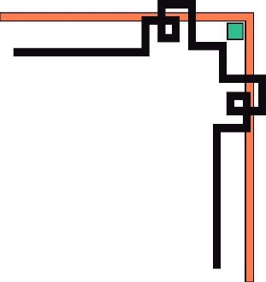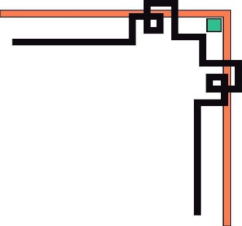

**HO CHI MINH UNIVERSITY OF TECHNOLOGY AND EDUCATION**

**FACULTY FOR HIGH QUALITY TRAINING**

**🕯✡🕮🕮✡🕯**



**SPECIALIZED ESSAY**

**LEARN ASP.NET CORE AND ANGULAR JS, BUILD A MOVIE REVIEWS AND TICKETS BOOKING WEBSITE**

**Mentor: PhD. Lê Văn Vinh**

**Student Name: Student ID**

**Tôn Nữ Như Quỳnh 17110214**

**Nguyễn Ngọc Tú Duyên 17110116**

Ho Chi Minh, December 23rd 2020



**HO CHI MINH UNIVERSITY OF TECHNOLOGY AND EDUCATION**

**FACULTY FOR HIGH QUALITY TRAINING**

**🕯✡🕮🕮✡🕯**



**SPECIALIZED ESSAY**

**LEARN ASP.NET CORE AND ANGULAR JS, BUILD A MOVIE REVIEWS AND TICKETS BOOKING WEBSITE**

**Mentor: PhD. Lê Văn Vinh**

**Student Name: Student ID**

**Tôn Nữ Như Quỳnh 17110214**

**Nguyễn Ngọc Tú Duyên 17110116**

Ho Chi Minh, December 23rd 2020

|  |  |
| --- | --- |
| HCM University of Technology and Education  **FACULTY FOR HIGH QUALITY TRAINING**  ⎯⎯⎯⎯⎯⎯⎯⎯⎯⎯⎯⎯⎯ | **SOCIALIST REPUBLIC OF VIETNAM**  **Independence – Freedom - Happiness**  ⎯⎯⎯⎯⎯⎯⎯⎯⎯ |

**OUTLINE OF SPECIALIZED ESSAY**

Name of student: Tôn Nữ Như Quỳnh Student ID: 17110214

Name of student: Nguyễn Ngọc Tú Duyên Student ID: 17110116

Major: Software Engineer.

Topic name: Analysis, design, contruction of Movie Reviews And Tickets system.

Mentor: PhD. Lê Văn Vinh.

**Content:**

*Theory:*

* Survey the current state of demand.
* Explore related systems as well as system operations

*Practice:* Apply to contruction of Movie Reviews And Tickets system.

**Execution time** from 09/09/2020 to 23/12/2020

Signature of student:

Signature of student:

|  |  |
| --- | --- |
|  | Ho Chi Minh, December 23rd 2020 |
| HEAD OF INFORMATION TECHNOLOGY | MENTOR |
| (Name and signature) | (Name and signature) |

|  |  |
| --- | --- |
|  | **SOCIALIST REPUBLIC OF VIETNAM**  **Independence – Freedom - Happiness**  ----***---- |

**COMMENTARY OF MENTOR**

Student name: Tôn Nữ Như Quỳnh Student ID: 17110214

Nguyễn Ngọc Tú Duyên 17110116

Major: Software Engineer.

Topic name: Analysis, design, contruction of Movie Reviews And Tickets system.

Name of supervisor: D.Sc. Lê Văn Vinh.

**COMMENTARY**

1. On content of topic & workload done:

1. Advantage:

1. Disadvantage:

4. Recommend for defense or not?

5.Rating type:

6. Mark: (By word: )

*Ho Chi Minh, ……………………………….* 2020

MENTOR

(Name and signature)

|  |  |
| --- | --- |
|  | **SOCIALIST REPUBLIC OF VIETNAM**  **Independence – Freedom - Happiness**  ----***---- |

**COMMENTARY OF REVIEWER**

Student name: Tôn Nữ Như Quỳnh Student ID: 17110214

Nguyễn Ngọc Tú Duyên 17110116

Major: Software Engineer.

Topic name: Analysis, design, contruction of Movie Reviews And Tickets system.

Name of reviewer:

**COMMENTARY**

1. On content of topic & workload done:

1. Advantage:

1. Disadvantage:

1. Recommend for defense or not?
2. Rating type:
3. Mark: (By word: )

*Ho Chi Minh, ……………………………….* 2020

REVIEWER

(Name and signature)

ASSURANCE

We assure that this project is our own implementation. We do not copy, use any material or source code of others without specifying the source. We assume responsibility for violations.

*Ho Chi Minh,* December 23rd 2020

Tôn Nữ Như Quỳnh Nguyễn Ngọc Tú Duyên

MANY THANKS

In this fact, there are no successes that are not associated with support or assistance, whether more or less, directly or indirectly by others. Now I would like to send this sincere thanks to PhD. Lê Văn Vinh, who directly guided us to complete this project, has supported and transmitted motivation to us in the process of choosing topics, instructions and comments. Although we do not ask much, but when asking the teacher for help, it is the motivation for us to complete the course, without the instructions and practical experiences of the teacher, I think the article This report will be difficult to complete and completed on time. Once again, I would like to thank the teacher.

I also would like to thank the teachers of the Faculty of Information Technology, Ho Chi Minh City University of Technical Education for teaching the student group to report, help and support answers so that the our report can complete the project implementation process.

Due to limited time, with limited knowledge and many other worries, there is an inevitable problem, so I look forward to receiving your valuable suggestions for my knowledge. more complete later. We sincerely thank you.

Ho Chi Minh, December 23rd 2020

Tôn Nữ Như Quỳnh Nguyễn Ngọc Tú Duyên

**Table of Contents**

CHAPTER 1. INTRODUCTION 14

1.1. Urgency and objectives of project 14

1.1.1. The urgency of project 14

1.1.2. Project objectives 14

1.2. Objects, scope and methods of research 14

1.2.1. Research objects 15

1.2.2. Research scope 15

1.3. Expected results 15

CHAPTER 2. SURVEY AND USER REQUIREMENT 16

2.1. Current systems 16

2.1.1. IMDb.com 16

2.1.2. Moveek 17

2.2. User requirement 20

2.2.1. Actor of system 20

2.2.2. Document Management System 23

2.2.3. Usecase Diagram 26

2.2.4. Usecase Description 29

2.2.5. Non-functional Requirement 96

2.2.6. Entity Relation Diagram (ERD) 98

CHAPTER 3. FUNDATMENTALS 100

3.1. Overview of ASP.NET Core 100

3.1.1. Introduction to ASP.NET Core 100

3.1.2. Features 100

3.1.3. Introduction to Web APIs in ASP.NET Core 100

3.1.4. Advantages of ASP.NET Core 101

3.1.5. ASP.NET Core in Project 101

3.2. Angular Framework 101

3.2.1. Introduction to Angular 101

3.2.2. Angular concepts 101

3.2.3. Angular in Project 102

CHAPTER 4. SYSTEM DESIGN 103

4.1. Class Diagram 103

4.1.1. Class diagram description of “CinemaChain_API” 105

4.1.2. Class digram descripton of “MovieReviewsAndTickets” 110

4.2. Sequence Diagram 116

4.2.1. Login 116

4.2.2. Add Movie 116

4.2.3. Write Review and Rate 118

4.2.4. Book tickets 118

4.3. Activity Diagram 120

4.3.1. Add Movie 120

4.3.2. Write Review and Rate 121

4.4. State Machine Diagram 122

4.4.1. Login 122

4.4.2. Book Tickets 122

4.5. Component Diagram 124

4.5.1. CinemaChain API 124

4.5.2. Movie Reviews & Tickets API 126

4.6. Interface Design 128

4.6.1. Login dialog 128

4.6.2. Seats of showtime screen 129

4.6.3. Review dialog 130

CHAPTER 5. IMPLEMENTATION AND TESTING 131

5.1. System Architecture 131

5.2. Tools in Project 132

5.3. Technologies in Project 132

5.4. Test Plan 133

5.4.1. Test Scenarios 133

5.4.2. Test Result 135

CHAPTER 6. CONCLUSION 145

6.1. Results 145

6.2. Advantages 145

6.3. Disadvantages 145

6.4. Development strategy 145

REFERENCES 146

**Table List**

**Table 1 –** SuperAdmin function 20

**Table 2 –** Admin function 21

**Table 3** **–** Guest function 22

**Table 4 –** Authorized user’s funtions 22

**Table 5 –** Login 30

**Table 6 –** Reset password 32

**Table 7 –** Like a movie 34

**Table 8 –** Write a review and rate 36

**Table 9 –** Like or Dislike a review 38

**Table 10 –** Log out 39

**Table 11 –** Update profile 40

**Table 12** – Change password 42

**Table 13** – View watchlist 44

**Table 14** – View order history 45

**Table 15** – Edit review 47

**Table 16** – Delete review 49

**Table 17** – Register 51

**Table 18** – View upcoming movies 52

**Table 19** – View movies in theaters 54

**Table 20** – View movie's details 55

**Table 21** – View movie's showtimes 57

**Table 22** – Book tickets 59

**Table 23** – Search movies 61

**Table 24** – View cinemas 63

**Table 25** – View cinema details 64

**Table 26** – View cinema chain 66

**Table 27** – Add movie 68

**Table 28** – Update movie's details 70

**Table 29** – Update movie's casts 73

**Table 30** – Delete movie 74

**Table 31** – Block user 76

**Table 32** – Unblock user 78

**Table 33** – Delete user 80

**Table 34** – Add cinema chain 82

**Table 35** – Update cinema's information 83

**Table 36** – Delete cinema chain 85

**Table 37** – Add Admin 87

**Table 38** – Delete admin 88

**Table 39** – Block admin 90

**Table 40** – Unblock admin 92

**Table 41** – Add cinemas 93

**Table 42** – Delete cinema 95

**Table 43 –** Cinema 104

**Table 44 –** CinemaChain 104

**Table 45 –** City 105

**Table 46 –** MoviesInCinemaChain 105

**Table 47** **–** Order 106

**Table 48 –** Room 106

**Table 49 –** RoomType 106

**Table 50 –** ScreenFormat 107

**Table 51 –** Seat 107

**Table 52 –** SeatsInOrder 108

**Table 53 –** SeatType 108

**Table 54 –** SeatTypeInChain 108

**Table 55 –** Showtime 109

**Table 56 –** CheckoutInfo 109

**Table 57 –** User 110

**Table 58 –** Account 110

**Table 59 –** Cast 110

**Table 60 –** Cinema 110

**Table 61 –** CinemaChain 111

**Table 62 –** Genre 111

**Table 63 –** Language 111

**Table 64 –** Movie 112

**Table 65 –** MovieLike 112

**Table 66 –** MovieStatus 113

**Table 67 –** Order 113

**Table 68 –** Review 114

**Table 69 –** ReviewLike 114

**Table 70 –** Role 114

**Table 71 –** SeatsInOrder 115

**Table 72 –** Component of CinemaChainAPI description 124

**Table 73 –** Component of MainBackend description 126

**Table 74 –** Login dialog objects 127

**Table 75 –** Seats of showtime screen objects 128

**Table 76 –** Review dialog objects 129

**Table 77 –** Tools using for project 131

**Table 78 –** Technologies using for project 132

**Table 79 –** Test Scenarios 133

**Table 80 –** Test results of Login function 135

**Table 81 –** Test results of Book tickets function 139

**Table 82 –** Test results of Add a movie function 142

**Image List**

**Image 1 –** Movie's information 15

**Image 2 –** User reviews 16

**Image 3 –** Overview website functionality 17

**Image 4 –** Review screen 18

**Image 5 –** Book tickets function 19

**Image 6** **–** Usecase of Project 25

**Image 7** **–** Usecase diagram for Admin 26

**Image 8 –** Usecase diagram for User 27

**Image 9 –** CinemaChainAPI 97

**Image 10 –** MovieReviews&TicketAPI 98

**Image 11 –** Class diagram of CinemaChainAPI 102

**Image 12 –** Class diagram of MovieReviewsAndTicketsAPI 103

**Image 13 –** Sequence diagram Login 115

**Image 14 –** Sequence diagram Add Movie 116

**Image 15 –** Sequence diagram Write Review and Rate 117

**Image 16 –** Sequence diagram Book Tickets 118

**Image 17 –** Activity diagram Add Movie 119

**Image 18 –** Activity diagram Write Review and Rate 120

**Image 19 –** State Machine diagram Login 121

**Image 20 –** State Machine diagram Book Tickets 122

**Image 21 –** Component diagram of CinemaChain_API 123

**Image 22 –** Component diagram of Mainbackend_API 125

**Image 23 –** Login dialog 127

**Image 24 –** Seats of showtime screen 128

**Image 25 –** Review dialog 129

**Image 26 –** Overview of architectural design for system 130

**Image 27 –** Expected & Actual result of TC_LI_01 136

**Image 28** **–** Expected & Actual result of TC_LI_02 136

**Image 29 –** Expected & Actual result of TC_LI_03 137

**Image 30 –** Expected & Actual result of TC_BT_01 140

**Image 31 –** Expected & Actual result of TC_BT_02 140

**Image 32 –** Expected & Actual result of TC_AM_01 143

**Image 33 –** Expected & Actual result of TC_AM_02 143

# CHAPTER 1. INTRODUCTION

## Urgency and objectives of project

### The urgency of project

Sometimes you see a movie coming out and find it interesting, but don't know if its content is right for you? Want reviews from people who have seen it? Or you simply want to know what the movie is about before taking the time to watch.

Besides expanding functions such as buying tickets through the website, it will save time buying at theaters and have the opportunity to buy tickets with satisfactory show times and seats…

The idea of a community that shares views on film and art as appropriate to social needs.

### Project objectives

Topic “LEARN ASP.NET CORE AND ANGULAR JS, BUILD A MOVIE REVIEWS AND TICKETS BOOKING WEBSITE” is solve the issues include:

- The group of students working on the project should have results research expertise and understand the generalization and applicability of Asp.net Core and Angular js. Using technologies, techniques, libraries applied to the software development process to develop website.

- Building the system for the movie reviews and ticket with the features to help users can use the website to see or write reviews about movies, book tickets online at home.

- In addition to finishing the functions of the system must also satisfy the requirements of security factors such as authentication form between the user and the server, the algorithm of encryption of private information, the corresponding mechanism of authorization system functions.

- The product is a website should require a user-friendly interface that is suitable for the subject that is intended.

## Objects, scope and methods of research

### Research objects

The project was conducted around two focus objects, including: the technologies and the practical knowledge about the management and operation of a movie reviews and book tickets system.

In which the object of technologies includes compulsory research objects: microservices architecture, open source ASP.NET Core, RESTful APIs, Angular framework, MS SQL Server database. Technologies used to deploy and operate the system include Somee, Firebase.

The objects of research subjects on practical knowledge about the management and operation of movie reviews and book tickets, including movie review, online booking ticket process, user and admin management, statistics and analysis of website activities.

### Research scope

The scope of the research is set at a general level, understands the general knowledge of the research content and applies each knowledge content to the actual product, without putting heavy theories and non-application.

## Expected results

- Understand the knowledge about ASP.NET Core, RESTful APIs, Angular framework.

- Build a movie reviews and tickets booking website with that knowledge.

# CHAPTER 2. SURVEY AND USER REQUIREMENT

## 2.1. Current systems

### 2.1.1. IMDb.com

#### 2.1.1.1. Introduction

Surely anyone, if you've ever visited famous online movie-watching websites in the country such as: phimmoi.net, xemtvhd.com, banhtv.com, vuviphim.com, hdonline.vn, ... then surely you have see IMDb Score. So have you ever wondered how the role of IMDb Score influences movies?

IMDb is the world's most popular and authoritative source for movie, TV and celebrity content, designed to help fans explore the world of movies and shows and decide what to watch.[2]

#### 2.1.1.2. Browse information about movie

Overview:

You can quickly search and view trailers, ratings, actors, and storylines. In addition, you can read reviews by reviewers and users. Now, you can decide if you want to watch that movie or search for another movie to watch instead.

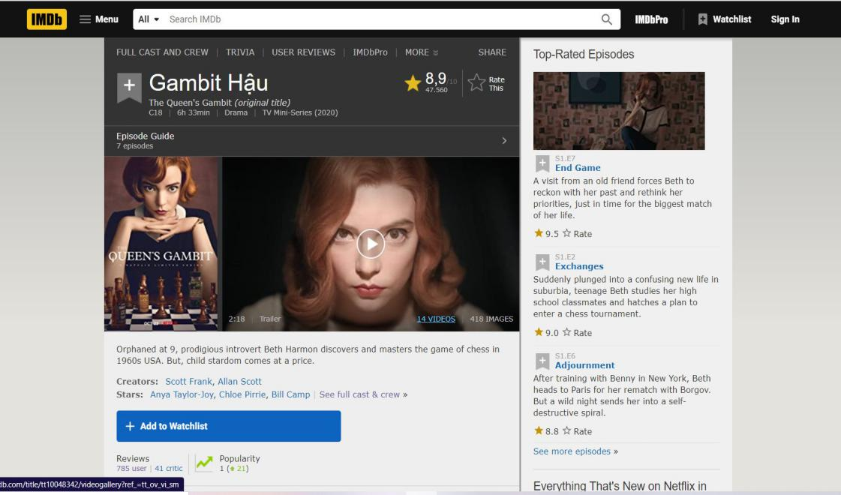

**Image 1 –** Movie's information

#### 2.1.1.3. User Reviews

Overview:

You can see everyone's rating of the movie as well as the rate score. In addition, upon successful registration of a member account of the site, we can leave a comment. We can choose whether or not this review will reveal content.

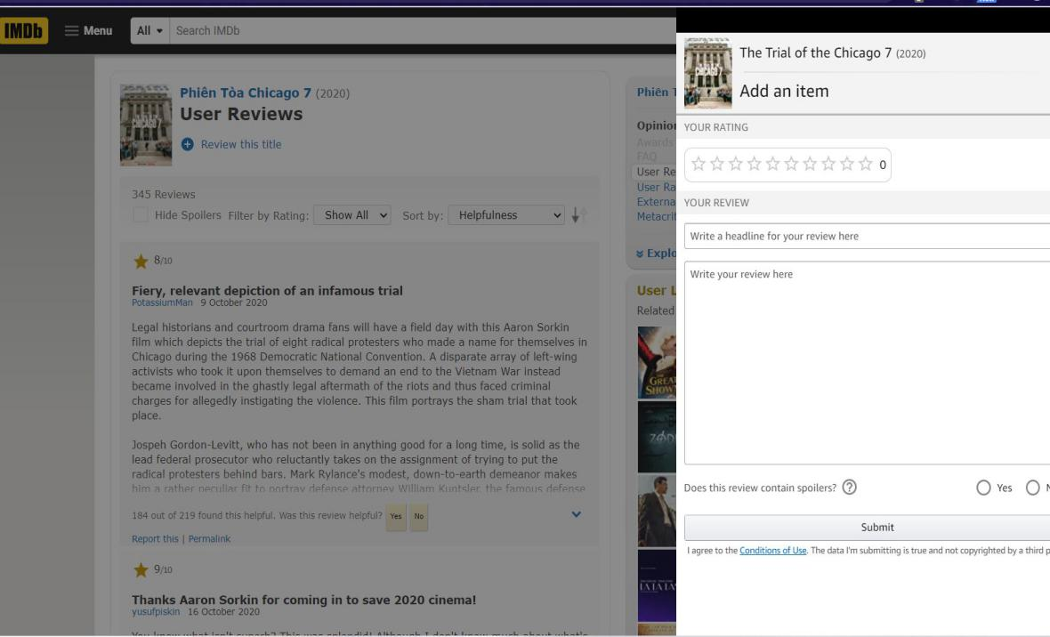

**Image 2 –** User reviews

### 2.1.2. Moveek

#### 2.1.2.1. Introduction

Moveek.com is an information site providing articles introducing and evaluating films shown in theaters across the country. In addition, Moveek also redistributes products and services of partners (theaters) on the website Moveek.com.[1]

Services are understood to include: movie tickets at co-operative theaters; corn - water or other foods provided by cooperative theaters; and items related to film promotion provided by the affiliated cinemas.

#### 2.1.2.2. Website functionality

Overview:

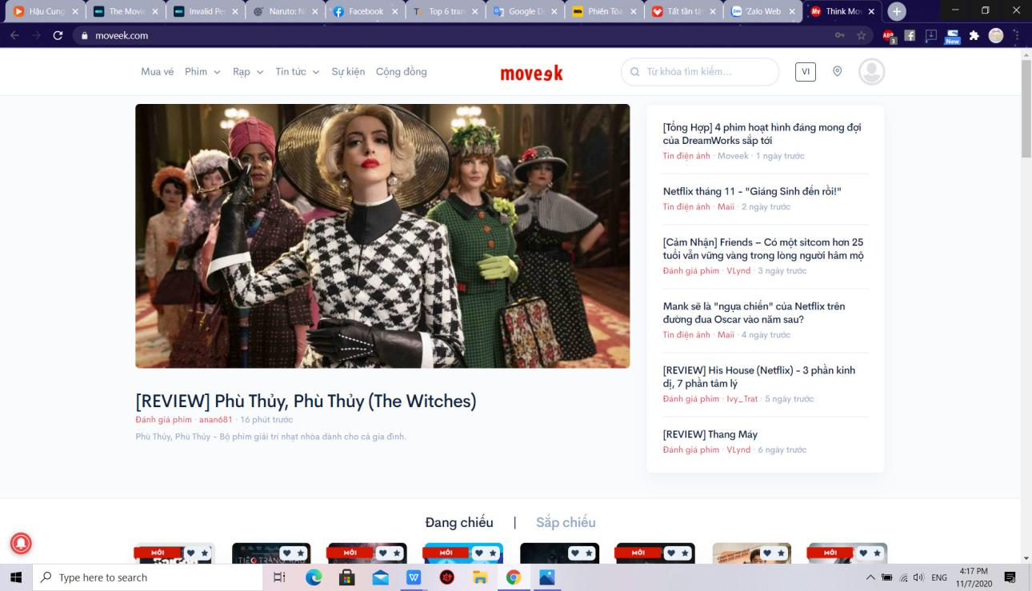

**Image 3 –** Overview website functionality

Home interface and functions:

* Book ticket: are movie tickets at movie theaters that Moveek cooperates. Customers can only purchase tickets online for theaters where Moveek has announced its Online Booking Partnership.
* Movie: see movie showtimes, list of movies is filtered by current, upcoming show..
* Cinema: list of theaters by region in cluster theaters working with moveek
* Information: Synthesize articles about movies, audience reviews, and related videos..

#### 2.1.2.3. Review function

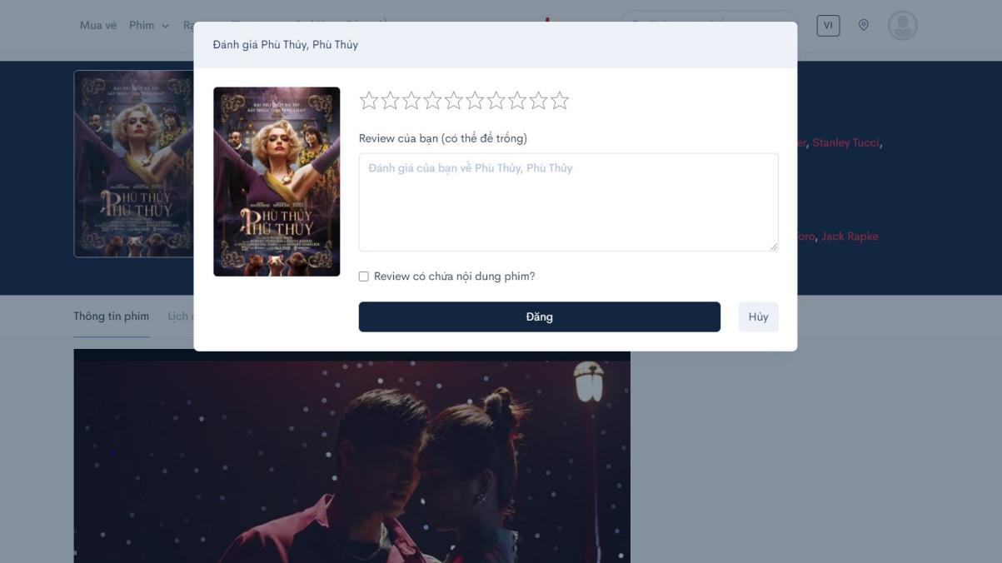

**Image 4 –** Review screen

You can see everyone's rating of the movie as well as the rate score. In addition, upon successful registration of a member account of the site, we can leave a comment. We can choose whether or not this review will reveal content.

#### 2.1.2.4. Book tickets

Customers can only purchase tickets online for theaters where Moveek has announced its Online Booking Partnership.

Customers can buy tickets and choose seats just like when buying tickets at the theater.

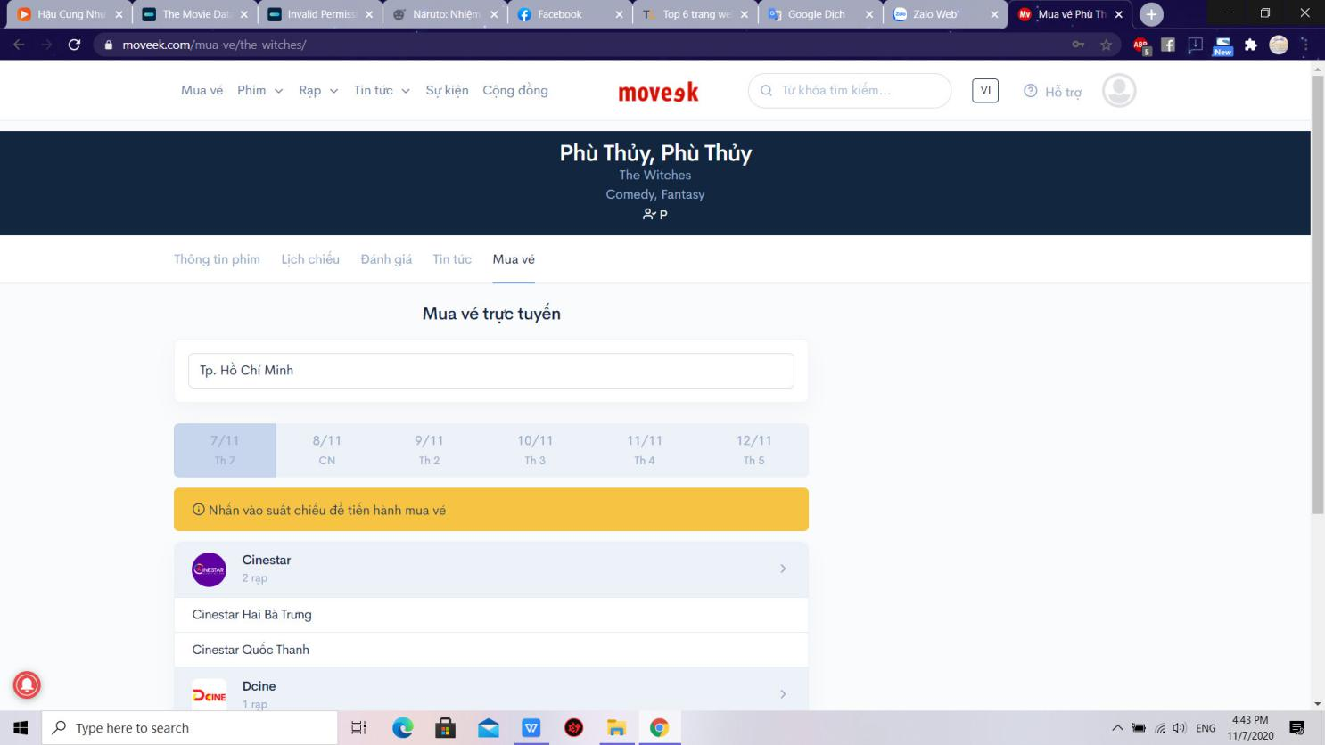

**Image 5 –** Book tickets function

## 2.2. User requirement

With the results of collecting and examining the current systems, we will build an easy-to-use website that is decentralized to admin and users.

### 2.2.1. Actor of system

Based on the description of the problem, we can identify the main actors of the system statistics are as follows:

- Super Admin: Use the system with the highest privileges. People who perform the functions of system administration, accounts, client, decentralizing for management, interface management. Super Administration functions in this system must be logged.

- Admin: Under Super Admin's control. Has movie management and user management rights, view statistic. Administration functions in this system must be logged.

- Authorized User: Inheriting all functions of Unauthorized User. Need to login to manage account, write reviews, like / unlike movies, view booking history.

- Guest: Can view showtimes, view reviews, view cinemas and book tickets also sign up for an account.

**Main functions:**

* **Super Admin’s functions:**

|  |  |  |
| --- | --- | --- |
|  | Function name | Description |
| 1 | Add Admin | Register Admin account for employees. |
| 2 | Delete Admin | Delete Admin account from website. |
| 3 | Block Admin | Block Admin account when suspended or disciplined. |
| 4 | UnBlock Admin | Unblock Admin account to continue operating the site. |
| 5 | Add cinema chain | Add cinema chain to website. |
| 6 | Delete cinema chain | Delete cinema chain from website. |
| 7 | Add cinemas | Add cinemas in cinema chain to website |
| 8 | Delete a cinema | Delete a cinema from website |
| 9 | Update cinema’s information | Update detailed information about the chain of cinemas such as location, quantity.. |

**Table 1 –** SuperAdmin function

* **Admin’s functions**

|  |  |  |
| --- | --- | --- |
|  | Function name | Description |
| 1 | Login | Enter username and password. Validation matches data. If available, the system will allow login to perform functions in the system. |
| 2 | Add Movie | Add movie and and classification to website. |
| 3 | Delete Movie | Delete movie from website. |
| 4 | Update movie’s cast | Update movie’s cast information |
| 5 | Update movie’s detail | Update detailed information about the movie such as datetime, trailers… |
| 6 | Block user | Block user account when suspended or disciplined. |
| 7 | Unblock user | Unblock Admin account to continue operating the site. |
| 8 | Update cinema’s information | Update detailed information about the chain of cinemas such as location, quantity.. |
| 9 | View statistics | See website analytics such as visits, interactions, ticket purchases.. |

**Table 2 –** Admin function

* **Guest functions**

|  |  |  |
| --- | --- | --- |
|  | Function name | Description |
| 1 | View movies in theaters | See information about movies being shown in cinemas. |
| 2 | View upcoming movies | See information about upcoming movies in cinemas. |
| 3 | View movie’s detail | View detailed movie information such as genre, actor, and screen time. |
| 4 | Search movies | Search for movies by keywords. |
| 5 | Search cinemas | Search for cinemas by keywords. |
| 6 | View cinema | The website navigates to the cinemas screen and displays a list of cinemas located in user’s city. |
| 7 | View cinema chain | Information about theaters is divided by regions for users to find easily |
| 8 | View cinema’s detail | Cinema information such as address, ticket price... |
| 9 | Register | Create an account as role “User”. |

**Table 3** **–** Guest function

* **Authorized User’s functions**

|  |  |  |
| --- | --- | --- |
|  | Function name | Description |
| 1 | Login | Enter username and password. Validation matches data. If available, the system will allow login to perform functions in the system. |
| 2 | Logout | Log out of the website |
| 3 | View movie’s detail | View detailed movie information such as genre, actor, and screen time. |
| 4 | Search movies | Search for movies by keywords. |
| 5 | View cinema | The website navigates to the cinemas screen and displays a list of cinemas located in user’s city. |
| 6 | View cinema chain | Information about theaters is divided by regions for users to find easily |
| 7 | View cinema’s detail | Cinema information such as address, ticket price... |

**Table 4 –** Authorized user’s funtions

### 2.2.2. Document Management System

This system will manage all documents, drawings, detailed description of the entire system, helping newcomers in construction and development can read and understand the system quickly and easily. In addition, this system will make maintenance and upgrades a breeze, or for transferring technology to a new team more easily and quickly.

Super Admin functions:

* + - Add/Delete/Block/Unblock admin.
    - Add/Delete cinema chain.
    - Update cinema’s information.
    - Implementing the functions of Admin and User.
    - Add cinemas.
    - Delete a cinema.

Admin functions:

* + - Delete/Block/Unblock User
    - Add/Delete movie.
    - Update movie’s cast
    - Update movie’s details
    - View Statistics

Guest functions:

* + - Register
    - View movies in theaters
    - View upcoming movies
    - View movie’s detail
    - Search movies.
    - View cinema
    - View cinema chain
    - View cinema’s detail

Authorized User functions:

* + - Login
    - Logout
    - Reset password
    - Update profile
    - Change password
    - Like/Unlike a movie
    - Write review and rate
    - View watchlist
    - Edit review
    - Delete review
    - Like or dislike a review
    - View order history

### 2.2.3. Usecase Diagram

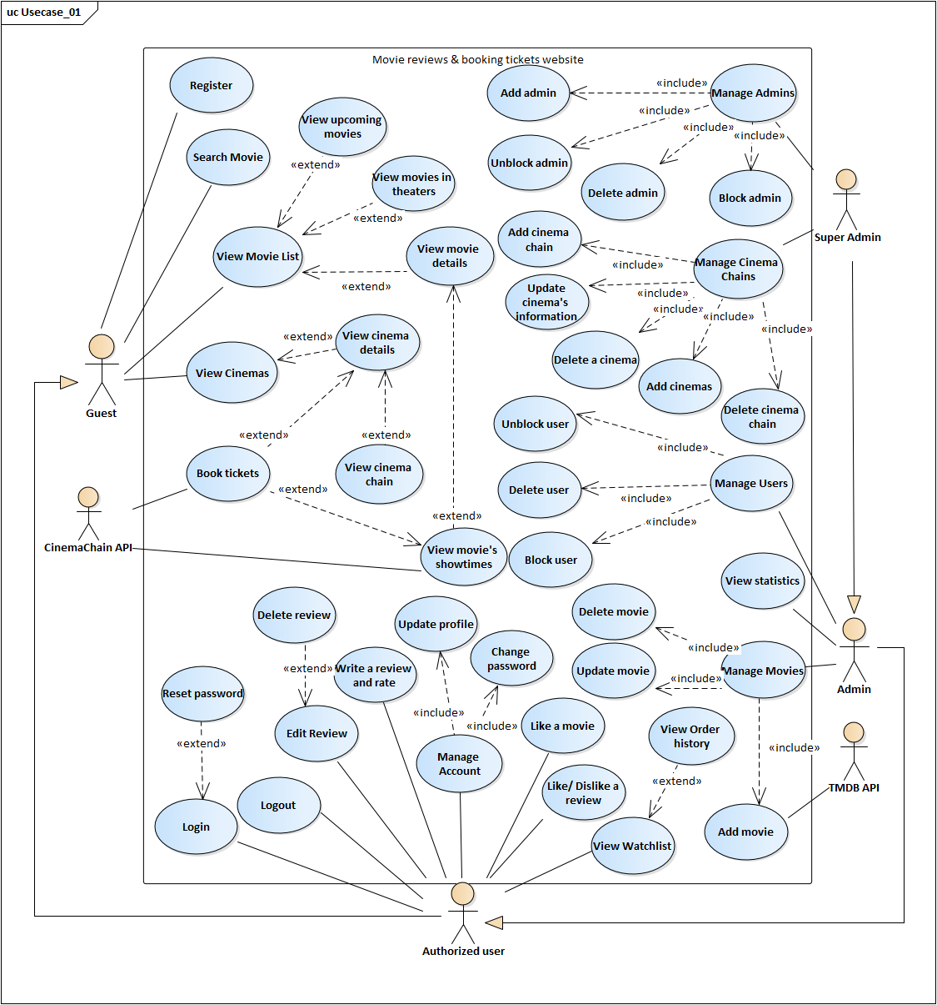

**Image 6** **–** Usecase of Project



**Image 7** **–** Usecase diagram for Admin

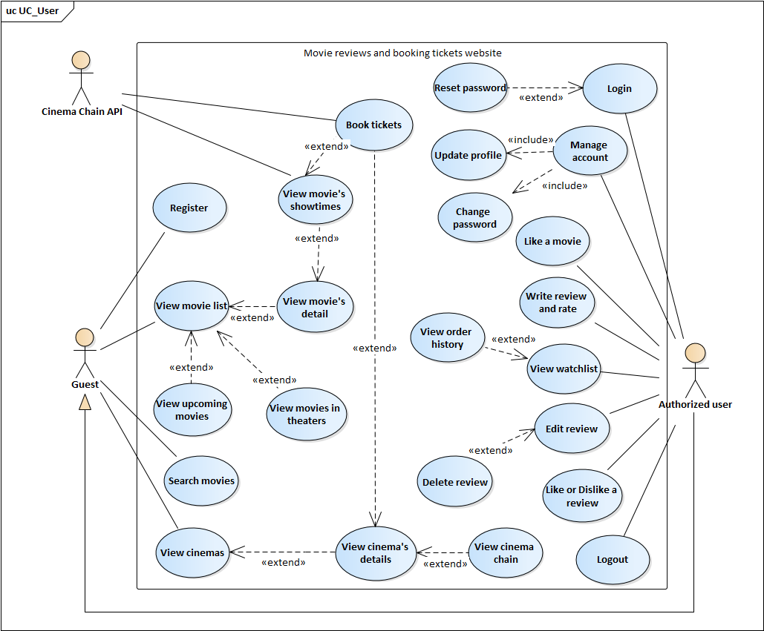

**Image 8 –** Usecase diagram for User

### 2.2.4. Usecase Description

#### 2.2.4.1. Functional requirements of “Authorized user”

2.2.4.1.1. Use case “Login”

|  |  |  |  |
| --- | --- | --- | --- |
| **USE CASE – MRABTW_UC_01** | | | |
| **Use Case No.** | MRABTW_UC_01 | **Use case version** | 1.0 |
| **Use case name** | Login | | |
| **Author** | Tôn Nữ Như Quỳnh | | |
| **Date** | 14/09/2020 | **Priority** | High |
| **Actor:**   * Authorized user   **Summary:**   * Allows Authorized user to login to the website.   **Goal:**   * User with authorization is logged in to the website with specific role.   **Triggers:**   * Users need to log in the website for some specific functions. * User click “Login” on the navigation bar.   **Preconditions:**   * User haven’t logged in to the website.   **Post conditions:**   * Succeeded: User is logged in to the website with specific role. * Failed: Error “Invalid user”.   **Main Success Scenario:**   |  |  |  | | --- | --- | --- | | **Step** | **Actor Action** | **System Response** | | 1 | Authorized user clicks “Login” on the right side of the navigation bar | The website shows the popup “Login” in the middle of the screen | | 2 | Authorized user types his/her name and password on the login form | [Exception 1]  [Exception 2]  [Exception 3] | | 3 | Authorized user clicks “Login”  [Alternative 1] | The popup disappears. On the right side of the navigation bar there will be the username of user  [Exception 4] |   **Alternative Scenario:**   |  |  |  | | --- | --- | --- | | **Step** | **Actor Action** | **System Response** | | 1 | Authorized user types “Enter” | The login form will be submitted and the website will validate the username and password |   **Exceptions:**   |  |  |  | | --- | --- | --- | | **No** | **Actor Action** | **System Response** | | 1 | Authorized user leaves username or password or both fields empty | Errors appear under the username or password input “Không được để trống trường này!” | | 2 | Username is not from 6 to 15 characters length, has special character or blank space | Errors appear under the username or password input “Tên đăng nhập không hợp lệ!” | | 3 | Password is not from 6 to 15 characters length | Errors appear under the username or password input “ Mật khẩu phải từ 6 - 15 kí tự!” | | 4 | Invalid username and password | Error appears on the top of login form “Tài khoản không tồn tại!” |   **Relationships:**  **Business Rules:**   * Username: must be 6 – 15 characters length with no special character and cannot be left empty. * Password: must be 6 – 15 characters length and cannot be left empty. | | | |

**Table 5 –** Login

2.2.4.1.2. Use case “Reset password”



|  |  |  |  |
| --- | --- | --- | --- |
| **USE CASE – MRABTW_UC_02** | | | |
| **Use Case No.** | MRABTW_UC_02 | **Use case version** | 1.0 |
| **Use case name** | Reset password | | |
| **Author** | Tôn Nữ Như Quỳnh | | |
| **Date** | 14/09/2020 | **Priority** | Low |
| **Actor:**   * Authorized user   **Summary:**   * Allows authorized user who forgot password to make a new password for his/her account.   **Goal:**   * Authorized user logins to the website with the new password.   **Triggers:**   * Authorized user forgot his/her password and clicks “Forgot password?” in the Login popup.   **Preconditions:**   * Authorized user haven’t logged in to the website.   **Post conditions:**   * Succeeded: User can login to the website with the new password. * Failed: User cannot login to the website with the new password.   **Main Success Scenario:**   |  |  |  | | --- | --- | --- | | **Step** | **Actor Action** | **System Response** | | 1 | Authorized user clicks “Login” on the right side of the navigation bar. | The Login popup appears at the center of the screen. | | 2 | Authorized user clicks “Forgot password?” at the right corner above the password input in the login form | The website navigate to reset password page. | | 3 | Authorized user types his/her registered email and clicks “Quên mật khẩu" | [Exception 1]  [Exception 2]  [Exception 3] | | 4 | Authorized user checks email and goes to the reset password link the website has sent. |  | | 5 | Authorized user types new password and confirm password. | [Exception 4] | | 6 | Authorized user clicks “Đặt lại” | Notification appears above the form “Đặt lại mật khẩu thành công” and the button “Về trang chủ” appears. |   **Alternative Scenario:**  **Exceptions:**   |  |  |  | | --- | --- | --- | | **No** | **Actor Action** | **System Response** | | 1 | User leaves email empty. | Error appears under the empty input “Không được bỏ trống trường này”, button “Gửi email” disables. | | 2 | User types invalid email | Error appears under the input “Email không hợp lệ!”, button “Gửi email” disables. | | 3 | User types email that does not exist | Error appears at the top right of the screen “Email chưa được đăng ký!”, button “Gửi email” disables. | | 4 | Password and confirm password don’t match | Error appears under the Confirm password input “Mật khẩu không trùng khớp!”. |   **Relationships:** MRABTW_UC_01 (Login)  **Business Rules:**   * Email: cannot be left empty and need existing. * Password and Confirm password: cannot be left empty and must match with each other. | | | |

**Table 6 –** Reset password

2.2.4.1.3. Use case “Like a movie”



|  |  |  |  |
| --- | --- | --- | --- |
| **USE CASE – MRABTW_UC_03** | | | |
| **Use Case No.** | MRABTW_UC_03 | **Use case version** | 1.0 |
| **Use case name** | Like a movie | | |
| **Author** | Tôn Nữ Như Quỳnh | | |
| **Date** | 15/09/2020 | **Priority** | Normal |
| **Actor:**   * Authorized user.   **Summary:**   * Allows user to like a movie and add this movie to his/her watchlist.   **Goal:**   * The heart symbol of the movie from gray turns to red and the movie will be added to the watchlist of user.   **Triggers:**   * User clicks the heart symbol of a movie in the movie list.   **Preconditions:**   * There’s no precondition for this usecase.   **Post conditions:**   * Succeeded: The heart symbol of the movie from gray turns to red. A green message appears at the top right corner of the screen “Like phim thành công!”. * Failed: The heart symbol of the movie doesn’t turns to red, no movie added to watchlist. A red message appears at the top right corner of the screen “Like phim không thành công!”.   **Main Success Scenario:**   |  |  |  | | --- | --- | --- | | **STEP** | **Actor Action** | **System Response** | | 1 | User clicks the heart symbol of a movie in the movie list screen  [Alternative 1]  [Alternative 2] | The heart symbol of the movie from gray turns to red. A green message appears at the top right corner of the screen “Like phim thành công!”.  [Exception 1] |   **Alternative Scenario:**   |  |  |  | | --- | --- | --- | | **No** | **Actor Action** | **System Response** | | 1 | User clicks the heart symbol of the movie in movie’s details screen |  | | 2 | User hasn’t logged in to the website | Popup login appears |   **Exceptions:**   |  |  |  | | --- | --- | --- | | **No** | **Actor Action** | **System Response** | | 1 |  | The heart symbol of the movie doesn’t turns to red, no movie added to watchlist. A red message appears at the top right corner of the screen “Like phim không thành công!”. |   **Relationships:**  **Business Rules:**   * Unauthorized user will need authorization to like a movie. | | | |

**Table 7 –** Like a movie

2.2.4.1.4. Use case “Write a review and rate”



|  |  |  |  |
| --- | --- | --- | --- |
| **USE CASE – MRABTW_UC_04** | | | |
| **Use Case No.** | MRABTW_UC_04 | **Use case version** | 1.0 |
| **Use case name** | Write a review and rate | | |
| **Author** | Tôn Nữ Như Quỳnh | | |
| **Date** | 15/09/2020 | **Priority** | Normal |
| **Actor:**   * Authorized user.   **Summary:**   * Allows user to rate and write view for a movie.   **Goal:**   * User’s review and rating for a movie will be displayed in the review list of that movie.   **Triggers:**   * User clicks “Đánh giá” in the movie’s details screen.   **Preconditions:**   * The website is in the movie details screen.   **Post conditions:**   * Succeeded: Page reloads, user’s review for the movie will be displayed in the review list of that movie. * Failed: Shows error.   **Main Success Scenario:**   |  |  |  | | --- | --- | --- | | **STEP** | **Actor Action** | **System Response** | | 1 | User clicks “Đánh giá” in the movie details screen. | Popup Review will be displayed at the center of movie detail screen. | | 2 | User rates and types review and ticks “Review có tiết lộ nội dung?” if the review contains spoilers |  | | 3 | User clicks “Đăng” | Page reloads, user’s review and rating for a movie will be displayed in the review list of that movie.  [Exception 1]  [Exception 2]  [Alternative 1] |   **Alternative Scenario:**   |  |  |  | | --- | --- | --- | | **No** | **Actor Action** | **System Response** | | 1 | User hasn’t logged in to the website | Popup Login will be displayed |   **Exceptions:**   |  |  |  | | --- | --- | --- | | **No** | **Actor Action** | **System Response** | | 1 | User writes a review but leaves the rating empty | Error in the Review form “Không được bỏ trống trường này!” | | 2 |  | Review form closes. A red message appears at the top right corner of the screen “Post đánh giá không thành công!”. |   **Relationships:** MRABTW_UC_16  **Business Rules:**   * Rating: must be rated. * Review: can be left empty if user already rates the movie. * User needs authorization to post a review. | | | |

**Table 8 –** Write a review and rate

2.2.4.1.5. Use case “Like or Dislike a review”



|  |  |  |  |
| --- | --- | --- | --- |
| **USE CASE – MRABTW_UC_05** | | | |
| **Use Case No.** | MRABTW_UC_05 | **Use case version** | 1.0 |
| **Use case name** | Like or Dislike a review | | |
| **Author** | Tôn Nữ Như Quỳnh | | |
| **Date** | 15/09/2020 | **Priority** | Normal |
| **Actor:**   * Authorized user.   **Summary:**   * Allows user to like or dislike a review.   **Goal:**   * The like (dislike) button below the review will be displayed in green (red for dislike).   **Triggers:**   * User clicks like or dislike button below the review.   **Preconditions:**   * The website is in the movie details screen.   **Post conditions:**   * Succeeded: The like (dislike) button below the review will be displayed in green (red for dislike).   **Main Success Scenario:**   |  |  |  | | --- | --- | --- | | **STEP** | **Actor Action** | **System Response** | | 1 | User clicks on the like (dislike) button below the review. | The like (dislike) button below the review will be displayed in green (red for dislike). The number counting likes or dislikes next to the button will be updated.  [Alternative 1] |   **Alternative Scenario:**   |  |  |  | | --- | --- | --- | | **No** | **Actor Action** | **System Response** | | 1 | User hasn’t logged in to the website | Popup Login will be displayed |   **Exceptions:**  **Relationships:**  **Business Rules:**   * User cannot like and dislike a review at the same time. * Unauthorized user when clicks on like/dislike button will need authorization to like or dislike a review. | | | |

**Table 9 –** Like or Dislike a review

2.2.4.1.6. Use case “Log out”



|  |  |  |  |
| --- | --- | --- | --- |
| **USE CASE – MRABTW_UC_06** | | | |
| **Use Case No.** | MRABTW_UC_06 | **Use case version** | 1.0 |
| **Use case name** | Log out | | |
| **Author** | Tôn Nữ Như Quỳnh | | |
| **Date** | 16/09/2020 | **Priority** | Normal |
| **Actor:**   * Authorized user   **Summary:**   * Allows user to log out of the website.   **Goal:**   * User logs out of the website becoming unauthorized user.   **Triggers:**   * User clicks “Logout” in the menu on the right side of the website’s navigation bar.   **Preconditions:**   * User has already logged in to the website.   **Post conditions:**   * Succeeded: User log out of the website becoming unauthorized user.   **Main Success Scenario:**   |  |  |  | | --- | --- | --- | | **STEP** | **Actor Action** | **System Response** | | 1 | User clicks “Logout” in the menu on the right side of the website’s navigation bar | The website navigates to the home page, username at the right side of the navigation bar disappears |   **Alternative Scenario:**  **Exceptions:**  **Relationships:**  **Business Rules:** | | | |

**Table 10 –** Log out

2.2.4.1.7. Use case “Update profile”



|  |  |  |  |
| --- | --- | --- | --- |
| **USE CASE – MRABTW_UC_07** | | | |
| **Use Case No.** | MRABTW_UC_07 | **Use case version** | 1.0 |
| **Use case name** | Update profile | | |
| **Author** | Tôn Nữ Như Quỳnh | | |
| **Date** | 16/09/2020 | **Priority** | Normal |
| **Actor:**   * Authorized user.   **Summary:**   * Allows user to change their profile’s information.   **Goal:**   * The changes user make in their profile will be saved.   **Triggers:**   * User clicks “Quản lý tài khoản” in the menu on the right side of the navigation’s bar.   **Preconditions:**   * User has logged in to the website.   **Post conditions:**   * Succeeded: The website notifies “Cập nhật thành công”. * Failed: The website shows error.   **Main Success Scenario:**   |  |  |  | | --- | --- | --- | | **STEP** | **Actor Action** | **System Response** | | 1 | User clicks “Quản lý tài khoản” in the menu on the right side of the navigation’s bar | The website navigates to the user’s profile screen to display user’s information. | | 2 | User types into those inputs which user want to change | [Exception 1] | | 3 | User clicks “Cập nhật” | The website saves changes into the database and shows message “Cập nhật thành công” |   **Alternative Scenario:**  **Exceptions:**   |  |  |  | | --- | --- | --- | | **No** | **Actor Action** | **System Response** | | 1 | User doesn’t type correct phone number format | Displays error above phone number input “Invalid phone number format” |   **Relationships:**  **Business Rules:**   * User cannot change username and email input. * Fullname, Region, Phone number could be left empty. * The profile image input cannot browse other file format except .png, .jpg, .jpeg. | | | |

**Table 11 –** Update profile

2.2.4.1.8. Use case “Change password”



|  |  |  |  |
| --- | --- | --- | --- |
| **USE CASE – MRABTW_UC_08** | | | |
| **Use Case No.** | MRABTW_UC_08 | **Use case version** | 1.0 |
| **Use case name** | Change password | | |
| **Author** | Tôn Nữ Như Quỳnh | | |
| **Date** | 16/09/2020 | **Priority** | Normal |
| **Actor:**   * Authorized user.   **Summary:**   * Allows user to changes his/her account’s password.   **Goal:**   * User’s new password will be saved into database and user can log in to the website by the new password.   **Triggers:**   * User clicks “Quản lý tài khoản” in the menu on the right side of the navigation’s bar, open the tab “Đổi mật khẩu” in profile screen.   **Preconditions:**   * User has logged in to the website.   **Post conditions:**   * Succeeded: The website shows message “Đổi mật khẩu thành công”. * Failed: The website shows error.   **Main Success Scenario:**   |  |  |  | | --- | --- | --- | | **STEP** | **Actor Action** | **System Response** | | 1 | User clicks “Quản lý tài khoản” in the menu on the right side of the navigation’s bar, open the tab “Đổi mật khẩu” in profile screen | The website navigates to the user’s profile screen then open tab “Đổi mật khẩu” | | 2 | User types the required inputs: Current password, New password, Confirm password | [Exception 1]  [Exception 2]  [Exception 3] | | 3 | User clicks “Đổi mật khẩu” | The website saves changes into the database and shows message “Đổi mật khẩu thành công”  [Exception 4] |   **Alternative Scenario:**  **Exceptions:**   |  |  |  | | --- | --- | --- | | **No** | **Actor Action** | **System Response** | | 1 | User leaves required inputs empty | Errors appear above those input “Không được bỏ trống trường này” | | 2 | User enter new password with incorrect format | Errors appear above those input “Mật khẩu phải từ 6 - 15 kí tự!” | | 3 | New password and confirm password don’t match | Error appears above Confirm password input “Mật khẩu không trùng khớp” | | 4 | Current password isn’t correct | Shows message “Mật khẩu hiện tại không đúng”. |   **Relationships:**  **Business Rules:**   * New password and Confirm password must match. * New password must be 6 to 15 characters length. * The required inputs: Current password, New password, Confirm password must be filled for user to be able to submit form. | | | |

**Table 12** – Change password

2.2.4.1.9. Use case “View Watchlist”



|  |  |  |  |
| --- | --- | --- | --- |
| **USE CASE – MRABTW_UC_09** | | | |
| **Use Case No.** | MRABTW_UC_09 | **Use case version** | 1.0 |
| **Use case name** | View Watchlist | | |
| **Author** | Tôn Nữ Như Quỳnh | | |
| **Date** | 16/09/2020 | **Priority** | Normal |
| **Actor:**   * Authorized user.   **Summary:**   * Allows user to view the list of movies he/she has rated and liked.   **Goal:**   * The website navigates to the watchlist screen and displays a list of movies he/she has rated and liked.   **Triggers:**   * User clicks “Tủ phim” in the menu on the right side of the navigation’s bar.   **Preconditions:**   * User has logged in to the website.   **Post conditions:**   * Succeeded: The website navigates to the watchlist screen and displays a list of movies he/she has rated and liked.   **Main Success Scenario:**   |  |  |  | | --- | --- | --- | | **STEP** | **Actor Action** | **System Response** | | 1 | User clicks “Tủ phim” in the menu on the right side of the navigation’s bar. | The website navigates to the watchlist screen and displays a list of movies he/she has rated and liked. |   **Alternative Scenario:**  **Exceptions:**  **Relationships:**  **Business Rules:** | | | |

**Table 13** – View watchlist

2.2.4.1.10. Use case “View order history”

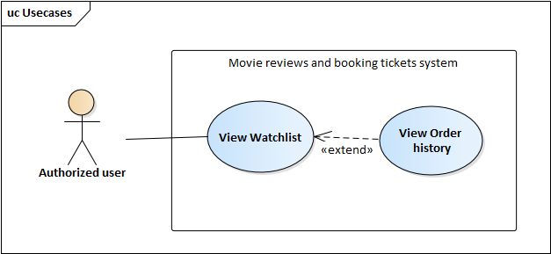

|  |  |  |  |
| --- | --- | --- | --- |
| **USE CASE – MRABTW_UC_10** | | | |
| **Use Case No.** | MRABTW_UC_10 | **Use case version** | 1.0 |
| **Use case name** | View Order history | | |
| **Author** | Tôn Nữ Như Quỳnh | | |
| **Date** | 16/09/2020 | **Priority** | Normal |
| **Actor:**   * Authorized user.   **Summary:**   * Allows user to view the list of orders he/she has made.   **Goal:**   * The website switches to tab “Vé đã mua” in Watchlist screen and displays a list of orders user has made.   **Triggers:**   * User clicks “Vé đã mua” tab in the watchlist screen.   **Preconditions:**   * User has logged in to the website.   **Post conditions:**   * Succeeded: The website switches to tab “Vé đã mua” in Watchlist screen and displays a list of orders user has made.   **Main Success Scenario:**   |  |  |  | | --- | --- | --- | | **STEP** | **Actor Action** | **System Response** | | 1 | User clicks “Vé đã mua” tab in the watchlist screen. | The website switches to tab “Vé đã mua” in Watchlist screen and displays a list of orders user has made. |   **Alternative Scenario:**  **Exceptions:**  **Relationships:** MRABTW_UC_10  **Business Rules:** | | | |

**Table 14** – View order history

2.2.4.1.11. Use case “Edit Review”



|  |  |  |  |
| --- | --- | --- | --- |
| **USE CASE – MRABTW_UC_11** | | | |
| **Use Case No.** | MRABTW_UC_11 | **Use case version** | 1.0 |
| **Use case name** | Edit Review | | |
| **Author** | Tôn Nữ Như Quỳnh | | |
| **Date** | 17/09/2020 | **Priority** | Normal |
| **Actor:**   * Authorized user.   **Summary:**   * Allows user to edit the review he/she wrote.   **Goal:**   * The changes will be saved to database and the review will be updated according to changes.   **Triggers:**   * User clicks “Đánh giá” in the movie details screen.   **Preconditions:**   * User has logged in to the website. * User is in the movie details screen of the movie for which user rated and wrote a review.   **Post conditions:**   * Succeeded: The changes user make will be saved to database and the review will be updated according to changes. * Failed: The review won’t be updated according to changes user make.   **Main Success Scenario:**   |  |  |  | | --- | --- | --- | | **STEP** | **Actor Action** | **System Response** | | 1 | User clicks “Đánh giá” in the movie details screen.  [Alternative 1] | Popup Review will be displayed at the center of movie detail screen and shows user’s review and rating of the movie | | 2 | User changes the rating, review or checkbox “Review có tiết lộ nội dung?” | [Exception 1] | | 3 | User clicks “Đăng” | User’s review for the movie will be updated in the review list of that movie. |   **Alternative Scenario:**   |  |  |  | | --- | --- | --- | | **No** | **Actor Action** | **System Response** | | 1 | User clicks the yellow star icon list in movie list screen |  |   **Exceptions:**   |  |  |  | | --- | --- | --- | | **No** | **Actor Action** | **System Response** | | 1 | User writes a review but leaves the rating empty | Error in the Review form “Không được để trống” |   **Relationships:**  **Business Rules:**   * User can only edit his/her review. * Rating: cannot be left empty. * Review: can be left empty if user already rates the movie. | | | |

**Table 15** – Edit review

2.2.4.1.12. Use case “Delete Review”



|  |  |  |  |
| --- | --- | --- | --- |
| **USE CASE – MRABTW_UC_12** | | | |
| **Use Case No.** | MRABTW_UC_12 | **Use case version** | 1.0 |
| **Use case name** | Delete review | | |
| **Author** | Tôn Nữ Như Quỳnh | | |
| **Date** | 17/09/2020 | **Priority** | Normal |
| **Actor:**   * Authorized user.   **Summary:**   * Allows user to delete his/her review for a movie.   **Goal:**   * The review will be disappear from the review list in movie’s details screen.   **Triggers:**   * User clicks “Đánh giá” in the movie details screen. * User clicks “Xóa review” button in the Review popup.   **Preconditions:**   * User has logged in to the website. * User is in the movie details screen of the movie for which user rated and wrote a review.   **Post conditions:**   * Succeeded: The website shows green message “Xóa đánh giá thành công” and the review will disappear from the review list in movie’s details screen. * Failed: The website show red message.   **Main Success Scenario:**   |  |  |  | | --- | --- | --- | | **STEP** | **Actor Action** | **System Response** | | 1 | User clicks “Đánh giá” in the movie details screen.  [Alternative 1] | Popup Review will be displayed at the center of movie detail screen and shows user’s review and rating of the movie | | 2 | User clicks “Xóa review” button in the Review popup. | Confirm dialog appears “Bạn có chắc muốn xóa bài đánh giá này?” | | 3 | User clicks “Yes”  [Alternative 2] | The website shows green message “Xóa thành đánh giá công”, page reloads & the review will disappear from the review list in movie’s details screen.  [Exception 1] |   **Alternative Scenario:**   |  |  |  | | --- | --- | --- | | **No** | **Actor Action** | **System Response** | | 1 | User clicks the yellow star icon list in movie list screen |  | | 2 | User clicks “No” | The Confirm dialog disappears. |   **Exceptions:**   |  |  |  | | --- | --- | --- | | **No** | **Actor Action** | **System Response** | | 1 |  | The website show red message “Xóa đánh giá không thành công!” |   **Relationships:** MRABTW_UC_11  **Business Rules:**   * User can only delete his/her review. | | | |

**Table 16** – Delete review

#### 2.2.4.2. Functional requirements of “Guest”

2.2.4.2.1. Use case “Register”



|  |  |  |  |
| --- | --- | --- | --- |
| **USE CASE – MRABTW_UC_13** | | | |
| **Use Case No.** | MRABTW_UC_13 | **Use case version** | 1.0 |
| **Use case name** | Register | | |
| **Author** | Tôn Nữ Như Quỳnh | | |
| **Date** | 14/09/2020 | **Priority** | High |
| **Actor:**   * Guest.   **Summary:**   * Allows guest to create an account as role “User”.   **Goal:**   * Guest becomes authorized user of the website with role as “User”.   **Triggers:**   * Guest who haven’t registered an account to the website. * Guest click on “Register” in the Login popup   **Preconditions:**   * Guest who doesn’t have an account.   **Post conditions:**   * Succeeded: Guest is logged in to the website as role “User” * Failed: Cannot create account.   **Main Success Scenario:**   |  |  |  | | --- | --- | --- | | **Step** | **Actor Action** | **System Response** | | 1 | Guest clicks “Register” on the right side of the navigation bar.  [Alternative 1] | The website navigate to the register screen. | | 2 | Guest types his/her email, username, passwords | [Exception 1], [Exception 2] | | 3 | Guest clicks “Tạo tài khoản”  [Alternative 2] | Notification appears above the register form “Tạo tài khoản thành công” and the website navigates back to home page.  [Exception 3] |   **Alternative Scenario:**   |  |  |  | | --- | --- | --- | | **Step** | **Actor Action** | **System Response** | | 1 | Guest clicks “Register” at the bottom of Login popup |  | | 2 | Guest types “Enter” | The register form will be submitted and the website will validate the input fields. |   **Exceptions:**   |  |  |  | | --- | --- | --- | | **No** | **Actor Action** | **System Response** | | 1 | Guest leaves username, passwords or empty. | Errors appear under the empty inputs “Không được bỏ trống trường này”. | | 2 | Password and confirm password don’t match | Error appears under the Confirm password input “Các mật khẩu không trùng khớp”. | | 3 | Reused email or username | Errors on the top of email or username input “Đã được sử dụng”. |   **Relationships:**  **Business Rules:**   * Username: cannot be left empty and cannot be reused. * Email: cannot be left empty and cannot be reused. * Password and Confirm password: cannot be left empty and must match with each other. | | | |

**Table 17** – Register

2.2.4.2.2. Use case “View upcoming movies”



|  |  |  |  |
| --- | --- | --- | --- |
| **USE CASE – MRABTW_UC_14** | | | |
| **Use Case No.** | MRABTW_UC_14 | **Use case version** | 1.0 |
| **Use case name** | View upcoming movies | | |
| **Author** | Tôn Nữ Như Quỳnh | | |
| **Date** | 15/09/2020 | **Priority** | High |
| **Actor:**   * Guest.   **Summary:**   * Allows user to view upcoming movies.   **Goal:**   * The website displays a list of upcoming movies.   **Triggers:**   * User clicks “Sắp chiếu” option in the menu “Phim” of navigation bar.   **Preconditions:**   * There’s no precondition for this use case.   **Post conditions:**   * Succeeded: The website directs to the movie list screen.   **Main Success Scenario:**   |  |  |  | | --- | --- | --- | | **STEP** | **Actor Action** | **System Response** | | 1 | User clicks “Sắp chiếu” option in the menu “Phim” of navigation bar | The website directs to the movie list screen displaying upcoming movies.  [Exception 1] |   **Alternative Scenario:**  **Exceptions:**   |  |  |  | | --- | --- | --- | | **No** | **Actor Action** | **System Response** | | 1 |  | The website displays “Không có phim sắp chiếu” |   **Relationships:**  **Business Rules:** | | | |

**Table 18** – View upcoming movies

2.2.4.2.3. Use case “View movies in theaters”



|  |  |  |  |
| --- | --- | --- | --- |
| **USE CASE – MRABTW_UC_15** | | | |
| **Use Case No.** | MRABTW_UC_15 | **Use case version** | 1.0 |
| **Use case name** | View movies in theaters | | |
| **Author** | Tôn Nữ Như Quỳnh | | |
| **Date** | 15/09/2020 | **Priority** | Normal |
| **Actor:**   * Guest.   **Summary:**   * Allows user to view movies now playing in theaters.   **Goal:**   * The website displays a list of movies on theaters.   **Triggers:**   * User clicks “Đang chiếu” option in the menu “Phim” of navigation bar.   **Preconditions:**   * There’s no precondition for this use case.   **Post conditions:**   * Succeeded: The website directs to the movie list screen.   **Main Success Scenario:**   |  |  |  | | --- | --- | --- | | **STEP** | **Actor Action** | **System Response** | | 1 | User clicks “Đang chiếu” option in the menu “Phim” of navigation bar | The website directs to the movie list screen displaying movies that are playing at the theaters.  [Exception 1] |   **Alternative Scenario:**  **Exceptions:**   |  |  |  | | --- | --- | --- | | **No** | **Actor Action** | **System Response** | | 1 |  | The website displays “Không có phim đang chiếu” |   **Relationships:**  **Business Rules:** | | | |

**Table 19** – View movies in theaters

2.2.4.2.4. Use case “View movie’s details”



|  |  |  |  |
| --- | --- | --- | --- |
| **USE CASE – MRABTW_UC_16** | | | |
| **Use Case No.** | MRABTW_UC_16 | **Use case version** | 1.0 |
| **Use case name** | View movie’s details | | |
| **Author** | Tôn Nữ Như Quỳnh | | |
| **Date** | 15/09/2020 | **Priority** | Normal |
| **Actor:**   * Guest.   **Summary:**   * Allows user to view details of a movie.   **Goal:**   * The website displays movie’s details.   **Triggers:**   * User clicks on a movie in the movie list screen.   **Preconditions:**   * There’s no precondition for this use case.   **Post conditions:**   * Succeeded: The website directs to the movie’s details screen. * Failed: The website directs to the Not Found screen.   **Main Success Scenario:**   |  |  |  | | --- | --- | --- | | **STEP** | **Actor Action** | **System Response** | | 1 | User clicks on a movie in the movie list screen | The website directs to the movie’s details screen displaying movie’s information, showtimes, reviews.  [Exception 1] |   **Alternative Scenario:**   |  |  |  | | --- | --- | --- | | **No** | **Actor Action** | **System Response** | | 1 | User clicks on a movie in the movie list in home page |  |   **Exceptions:**   |  |  |  | | --- | --- | --- | | **No** | **Actor Action** | **System Response** | | 1 |  | The website directs to the Not Found screen. |   **Relationships:**  **Business Rules:** | | | |

**Table 20** – View movie's details

2.2.4.2.5. Use case “View movie’s showtimes”



|  |  |  |  |
| --- | --- | --- | --- |
| **USE CASE – MRABTW_UC_17** | | | |
| **Use Case No.** | MRABTW_UC_17 | **Use case version** | 1.0 |
| **Use case name** | View movie’s showtimes | | |
| **Author** | Tôn Nữ Như Quỳnh | | |
| **Date** | 15/09/2020 | **Priority** | Normal |
| **Actor:**   * Guest.   **Summary:**   * Allows user to view the movie’s showtimes at theaters that are located in the user’s city.   **Goal:**   * The website displays the movie’s showtimes in specific cinemas.   **Triggers:**   * User clicks “Lịch chiếu” tab in the movie details screen.   **Preconditions:**   * The website is in the movie details screen.   **Post conditions:**   * Succeeded: The website displays the movie’s showtimes in every cinema located at user’s city.   **Main Success Scenario:**   |  |  |  | | --- | --- | --- | | **STEP** | **Actor Action** | **System Response** | | 1 | User clicks the tab “Lịch chiếu” in the movie details screen.  [Alternative 1] | Displays a list of cinema chains which has showtimes of the movie on that day, in located city. | | 2 | User clicks on a cinema chain | Display a list of cinemas located in user’s city | | 3 | User clicks on a cinema in the list | Displays a list of showtimes of the movie in that cinema |   **Alternative Scenario:**   |  |  |  | | --- | --- | --- | | **No** | **Actor Action** | **System Response** | | 1 | User clicks “Mua vé” button in the movie details screen |  |   **Exceptions:**  **Relationships:** MRABTW_UC_16  **Business Rules:**   * The showtime which is already passed will has color gray. | | | |

**Table 21** – View movie's showtimes

2.2.4.2.6. Use case “Book tickets”



|  |  |  |  |
| --- | --- | --- | --- |
| **USE CASE – MRABTW_UC_18** | | | |
| **Use Case No.** | MRABTW_UC_18 | **Use case version** | 1.0 |
| **Use case name** | Book tickets | | |
| **Author** | Nguyễn Ngọc Tú Duyên | | |
| **Date** | 21/10/2020 | **Priority** | Normal |
| **Actor:**   * Guest.   **Summary:**   * Allows user to book the movie’s tickets from cinemas that are cooperate with “Movie Review and Tickets ”.   **Goal:**   * User can book the movie’s tickets valid as tickets purchased at cinema.   **Triggers:**   * User picks a showtimes in the movie’ showtime list.   **Preconditions:**  **Post conditions:**   * Succeeded: User get an email and a SMS which user fills in the checkout page to inform the tickets info. * Failed: Website show errors.   **Main Success Scenario:**   |  |  |  | | --- | --- | --- | | **STEP** | **Actor Action** | **System Response** | | 1 | User go to Movie details page | Display movies’s details | | 2 | User clicks the tab “Lịch chiếu” | Display a list showtimes in that day and in located city. | | 3 | User clicks on an available showtime | The website navigates to Booking page displaying seats of the showtime. | | 4 | User clicks on a showtime in list | Display a list of rows and countdown booking seat time. | | 5 | User chooses seat number in list then clicks “Tiếp tục”.  [Alternative 1] | Display the Checkout page | | 6 | User fills in information form then clicks on “Thanh toán”.  [Exception 1]  [Alternative 1] | Display Stripe payment form | | 7 | User fills in the card’s info in Stripe payment form and clicks “Pay ...”  [Alternative 1] | The page displays loading circle and navigates to the Ticket details page displaying Tickets’s information. User also receives email and SMS informing tickets are booked sucessfully.  [Exception 2]  [Exception 3] |   **Alternative Scenario:**   |  |  |  | | --- | --- | --- | | **No** | **Actor Action** | **System Response** | | 1 | User hasn’t finished the order after 5 minutes | A dialog appears “Hết thời gian giữ ghế. Hãy thực hiện lại đơn hàng của bạn” |   **Exceptions:**   |  |  |  | | --- | --- | --- | | **No** | **Actor Action** | **System Response** | | 1 | User leaves required inputs empty | Errors appear beneath inputs, button “Thanh toán” disables. | | 2 | One or more of the seats user picked were picked by someone else before the order was posted to the system | A dialog appears “Đã xảy ra lỗi, hãy thực hiện lại đơn hàng của bạn” | | 3 | User’s Card is unable to be charged | A red message appears at the top right corner of the screen “Thông tin thẻ không hợp lệ!” |   **Relationships:** MRABTW_UC_17 (View movie’s showtimes), MRABTW_UC_23 (View cinema’s details)  **Business Rules:**   * The seat reservation time is 5 minutes, after that if user hasn’t finished order, user will be asked to come back previous page. * The email in Checkout form is the email user wants website to send tickets’ information, the email in Stripe payment is the email of the card’s owner. | | | |

**Table 22** – Book tickets

2.2.4.2.7. Use case “Search movie”



|  |  |  |  |
| --- | --- | --- | --- |
| **USE CASE – MRABTW_UC_19** | | | |
| **Use Case No.** | MRABTW_UC_19 | **Use case version** | 1.0 |
| **Use case name** | Search movies | | |
| **Author** | Tôn Nữ Như Quỳnh | | |
| **Date** | 15/09/2020 | **Priority** | Normal |
| **Actor:**   * Guest.   **Summary:**   * Allows user to search movies matching the keyword.   **Goal:**   * The website navigates to the search screen and displays list of movies matching the search keyword.   **Triggers:**   * User types “Enter” after typing a search string or clicks the search symbol next to the search input.   **Preconditions:**   * User is in the home page of the website where the search bar is.   **Post conditions:**   * Succeeded: The website navigates to the search screen and displays list of movies matching the search keyword.   **Main Success Scenario:**   |  |  |  | | --- | --- | --- | | **STEP** | **Actor Action** | **System Response** | | 1 | User types the search keyword into the search input in home page and clicks the search symbol on the right side of the input  [Alternative 1] | The website navigates to the search screen and displays list of movies matching the search keyword.  [Alternative 2] |   **Alternative Scenario:**   |  |  |  | | --- | --- | --- | | **No** | **Actor Action** | **System Response** | | 1 | User types “Enter” after typing the search string |  | | 2 |  | Displays “Không có kết quả tìm kiếm cho ...” |   **Exceptions:**  **Relationships:**  **Business Rules:** | | | |

**Table 23** – Search movies

2.2.4.2.8. Use case “View Cinemas”



|  |  |  |  |
| --- | --- | --- | --- |
| **USE CASE – MRABTW_UC_20** | | | |
| **Use Case No.** | MRABTW_UC_20 | **Use case version** | 1.0 |
| **Use case name** | View Cinemas | | |
| **Author** | Tôn Nữ Như Quỳnh | | |
| **Date** | 15/09/2020 | **Priority** | Normal |
| **Actor:**   * Unauthorized user.   **Summary:**   * Allows user to view cinemas located in user’s city.   **Goal:**   * The website navigates to the cinemas screen and displays a list of cinemas located in user’s city.   **Triggers:**   * User clicks “Rạp phim” button on the left side of the navigation bar.   **Preconditions:**   * There’s no precondition for this usecase.   **Post conditions:**   * Succeeded: A dialog shows up displaying a list of cinemas in user’s located city.   **Main Success Scenario:**   |  |  |  | | --- | --- | --- | | **STEP** | **Actor Action** | **System Response** | | 1 | User clicks “Rạp phim” button on the left side of the navigation bar | A dialog shows up displaying a list of cinemas in user’s located city. |   **Alternative Scenario:**  **Exceptions:**  **Relationships:**  **Business Rules:** | | | |

**Table 24** – View cinemas

2.2.4.2.9. Use case “View cinema details”



|  |  |  |  |
| --- | --- | --- | --- |
| **USE CASE – MRABTW_UC_21** | | | |
| **Use Case No.** | MRABTW_UC_21 | **Use case version** | 1.0 |
| **Use case name** | View cinema details | | |
| **Author** | Tôn Nữ Như Quỳnh | | |
| **Date** | 16/09/2020 | **Priority** | Normal |
| **Actor:**   * Unauthorized user.   **Summary:**   * Allows user to view cinema’s details.   **Goal:**   * The website navigates to the cinema’s detail screen and displays cinema’s information.   **Triggers:**   * User clicks on a cinema in the cinema list screen.   **Preconditions:**   * The website is in the cinema list screen.   **Post conditions:**   * Succeeded: The website navigates to the cinema’s detail screen and displays cinema’s information. * Failed: The website navigates to Not Found page.   **Main Success Scenario:**   |  |  |  | | --- | --- | --- | | **STEP** | **Actor Action** | **System Response** | | 1 | User clicks on a cinema in the cinema list screen | The website navigates to the cinema’s detail screen and displays cinema’s information includes: details, map, showtimes.  [Exception 1] |   **Alternative Scenario:**  **Exceptions:**   |  |  |  | | --- | --- | --- | | **No** | **Actor Action** | **System Response** | | 1 | The cinema user wants to see is deleted. | The website navigates to Not Found page. |   **Relationships:** View Cinemas (MRABTW_UC_20), Book tickets (MRABTW_UC_18), View cinema chain (MRABTW_UC_22)  **Business Rules:** | | | |

**Table 25** – View cinema details

2.2.4.2.10. Use case “View cinema chain”



|  |  |  |  |
| --- | --- | --- | --- |
| **USE CASE – MRABTW_UC_22** | | | |
| **Use Case No.** | MRABTW_UC_22 | **Use case version** | 1.0 |
| **Use case name** | View cinema chain | | |
| **Author** | Tôn Nữ Như Quỳnh | | |
| **Date** | 16/09/2020 | **Priority** | Normal |
| **Actor:**   * Guest.   **Summary:**   * Allows user to view the cinema chain that the cinema belongs to.   **Goal:**   * The website navigates to the cinema chain screen and displays cinemas in that cinema chain.   **Triggers:**   * User clicks the cinema chain’s name below the name of the cinema in the cinema’s details screen   **Preconditions:**   * The website is in the cinema’s details screen.   **Post conditions:**   * Succeeded: The website navigates to the cinema chain screen and displays cinemas in that cinema chain.   **Main Success Scenario:**   |  |  |  | | --- | --- | --- | | **STEP** | **Actor Action** | **System Response** | | 1 | User clicks the cinema chain’s name below the cinema’s name in the cinema details screen | The website navigates to the cinema chain screen and displays cinemas in that cinema chain  [Exception 1] |   **Alternative Scenario:**  **Exceptions:**   |  |  |  | | --- | --- | --- | | **No** | **Actor Action** | **System Response** | | 1 | The cinema chain user wants to see is deleted. | The website navigates to Not Found page. |   **Relationships:** View cinema details (MRABTW_UC_21)  **Business Rules:** | | | |

**Table 26** – View cinema chain

#### 2.2.4.3. Functional requirements of “Admin”

2.2.4.3.1. Use case “Add movie”



|  |  |  |  |
| --- | --- | --- | --- |
| **USE CASE – MRABTW_UC_23** | | | |
| **Use Case No.** | MRABTW_UC_23 | **Use case version** | 1.0 |
| **Use case name** | Add movie | | |
| **Author** | Nguyễn Ngọc Tú Duyên | | |
| **Date** | 12/10/2020 | **Priority** | Normal |
| **Actor:**   * Admin   **Summary:**   * Allows Admin to add a new movie for the website.   **Goal:**   * New movie being added to the database.   **Triggers:**   * Admin enters the “Quản lý phim” page. * Admin clicks “Thêm phim”.   **Preconditions:**   * Admin has logged in to website as Admin or Super Admin.   **Post conditions:**   * Success: website shows message “Thêm phim thành công”. * Failed: website shows message “Thêm phim không thành công”.   **Main Success Scenario:**   |  |  |  | | --- | --- | --- | | **STEP** | **Actor Action** | **System Response** | | 1 | Admin clicks “Thêm phim” button at the left side of the movie list table in the “Quản lý phim” page | The website directs to the “Thêm phim” page, displays a list of upcoming movies. | | 2 | Admin clicks at the plus button of a movie | Dialog “Thêm phim” appears to show user the movie’s details | | 3 | Admin enters the empty fields and modifies some movie’s details | [Exception 1]  [Exception 2] | | 4 | Admin clicks “Lưu” | Dialog “Thêm phim” disappears, a green message appears on the top right corner of the screen “Thêm phim thành công”  [Exception 3] |   **Alternative Scenario:**  **Exceptions:**   |  |  |  | | --- | --- | --- | | **No** | **Actor Action** | **System Response** | | 1 | Admin leaves required fields empty | Error appears under the empty input “Không được bỏ trống trường này”. The “Lưu” button stays disabled. | | 2 | Admin enters wrong format for the “Poster”, “Backdrop” or “Trailer” input | Error appears under the input “Url không hợp lệ!” | | 3 | The movie already exists in the database | Dialog “Thêm phim” disappears, a red message appears on the top right corner of the screen “Phim đã được thêm rồi!” |   **Relationships:**  **Business Rules:**   * “Tựa gốc”, “Tựa việt”, “Ngôn ngữ”, “Thể loại”, “Trạng thái”, “Thời gian”, “Ngày chiếu” inputs: cannot be left empty. * “Thời gian” input’s value must be integer from 0 to 9999. * “Poster”, “Backdrop” inputs: have to be url. * “Trailer” input must be url and must start with “https://youtube.com/embed”. | | | |

**Table 27** – Add movie

2.2.4.3.2. Use case “Update movie’s details”



|  |  |  |  |
| --- | --- | --- | --- |
| **USE CASE – MRABTW_UC_24** | | | |
| **Use Case No.** | MRABTW_UC_24 | **Use case version** | 1.0 |
| **Use case name** | Update movie’s details | | |
| **Author** | Nguyễn Ngọc Tú Duyên | | |
| **Date** | 13/10/2020 | **Priority** | Normal |
| **Actor:**   * Admin   **Summary:**   * Allows Admin to update the movie’s details.   **Goal:**   * Changes Admin has made will be saved into the database.   **Triggers:**   * Admin enters the “Quản lý phim” page. * Admin clicks the edit icon of a movie and picks the “Chi tiết phim”option.   **Preconditions:**   * Admin has logged in to website as an Admin or Super Admin.   **Post conditions:**   * Success: website shows message “Cập nhật phim thành công”. * Failed: website shows message “Cập nhật phim không thành công”.   **Main Success Scenario:**   |  |  |  | | --- | --- | --- | | **STEP** | **Actor Action** | **System Response** | | 1 | Admin clicks the edit icon of a movie | A dropdown menu with two options: “Chi tiết phim” và “Diễn viên” is displayed | | 2 | Admin clicks “Chi tiết phim” | Dialog “Cập nhật phim” appears to show user the movie’s details | | 3 | Admin modifies the desired fields | [Exception 1]  [Exception 2] | | 4 | Admin clicks “Lưu” | Dialog “Cập nhật phim” disappears, a green message appears on the top right corner of the screen “Cập nhật phim thành công”  [Exception 3] |   **Alternative Scenario:**  **Exceptions:**   |  |  |  | | --- | --- | --- | | **No** | **Actor Action** | **System Response** | | 1 | Admin leaves required fields empty | Error appears under the empty input “Không được bỏ trống trường này”. The “Lưu” button stays disabled. | | 2 | Admin enters wrong format for the “Poster”, “Backdrop” or “Trailer” input | Error appears under the input “Url không hợp lệ!” | | 3 |  | Dialog “Thêm phim” disappears, a red message appears on the top right corner of the screen “Cập nhật phim không thành công!” |   **Relationships:**  **Business Rules:**   * “Tựa gốc”, “Tựa việt”, “Ngôn ngữ”, “Thể loại”, “Trạng thái”, “Thời gian”, “Ngày chiếu” inputs: cannot be left empty. * “Thời gian” input’s value must be integer from 0 to 9999. * “Poster”, “Backdrop” inputs: have to be url. * “Trailer” input must be url and must start with “https://youtube.com/embed”. | | | |

**Table 28** – Update movie's details

2.2.4.3.3. Use case “Update movie’s casts”



|  |  |  |  |
| --- | --- | --- | --- |
| **USE CASE – MRABTW_UC_25** | | | |
| **Use Case No.** | MRABTW_UC_25 | **Use case version** | 1.0 |
| **Use case name** | Update movie’s casts | | |
| **Author** | Nguyễn Ngọc Tú Duyên | | |
| **Date** | 13/10/2020 | **Priority** | Normal |
| **Actor:**   * Admin   **Summary:**   * Allows Admin to update the movie’s details.   **Goal:**   * Changes Admin has made for the movie’s casts will be saved into the database.   **Triggers:**   * Admin enters the “Quản lý phim” page. * Admin clicks the edit icon of a movie and picks the “Diễn viên”option.   **Preconditions:**   * Admin has logged in to website as an Admin or Super Admin.   **Post conditions:**   * Success: website shows message “Cập nhật phim thành công”. * Failed: website shows message “Cập nhật phim không thành công”.   **Main Success Scenario:**   |  |  |  | | --- | --- | --- | | **STEP** | **Actor Action** | **System Response** | | 1 | Admin clicks the edit icon of a movie | A dropdown menu with two options: “Chi tiết phim” và “Diễn viên” is displayed | | 2 | Admin clicks “Diễn viên” option | Dialog “Diễn viên của phim” appears to show user the movie’s details | | 3 | Admin picks a cast in the list to edit  [Alternative 1]  [Alternative 2] | Name and character of the picked actor will be displayed in the input. Button “Thêm diễn viên” will be changed to “Cập nhật” | | 4 | Admin modifies the required input | [Exception 1]  [Exception 2] | | 5 | Admin clicks “Cập nhật”  [Alternative 3]  [Alternative 4] | The cast is updated in the cast list. A green message appears above the cast list “Đã cập nhật thay đổi” | | 6 | Admin clicks “Lưu” button | Dialog “Cập nhật phim” disappears, a green message appears on the top right corner of the screen “Cập nhật phim thành công”.  [Exception 3] |   **Alternative Scenario:**   |  |  |  | | --- | --- | --- | | **No** | **Actor Action** | **System Response** | | 1 | Admin doesn’t pick a cast to edit but instead, Admin types the input to add a new cast. |  | | 2 | Admin clicks the X icon to delete a cast off the list. | The picked cast is deleted from the cast list. | | 3 | Admin clicks “Thêm diễn viên” | The new cast appears in the cast list. A green message appears above the cast list “Đã thêm diễn viên”  [Exception 5] |   **Exceptions:**   |  |  |  | | --- | --- | --- | | **No** | **Actor Action** | **System Response** | | 1 | Admin leaves required fields empty | Error appears under the empty input “Không được bỏ trống trường này”. The “Cập nhật” button stays disabled. | | 2 | Admin enters wrong format for the “Poster”, “Backdrop” or “Trailer” input | Error appears under the input “Url không hợp lệ!” | | 3 |  | Dialog “Diễn viên của phim” disappears, a red message appears on the top right corner of the screen “Cập nhật phim không thành công!” | | 4 | Admin add an existed actor to the list | A red text appears above the “Tên diễn viên” input: “Diễn viên đã có rồi” |   **Relationships:**  **Business Rules:**   * “Tên diễn viên”, “Nhân vật” inputs: cannot be left empty. | | | |

**Table 29** – Update movie's casts

2.2.4.3.4. Use case “Delete movie”



|  |  |  |  |
| --- | --- | --- | --- |
| **USE CASE – MRABTW_UC_26** | | | |
| **Use Case No.** | MRABTW_UC_26 | **Use case version** | 1.0 |
| **Use case name** | Delete movie | | |
| **Author** | Nguyễn Ngọc Tú Duyên | | |
| **Date** | 13/10/2020 | **Priority** | Normal |
| **Actor:**   * Admin   **Summary:**   * Allows Admin to delete a movie.   **Goal:**   * The movie and its reference data will be deleted from the website   **Triggers:**   * Admin enters the “Quản lý phim” page. * Admin clicks the delete icon of a movie.   **Preconditions:**   * Admin has logged in to website as an Admin or Super Admin.   **Post conditions:**   * Success: website shows message “Xóa phim thành công”. * Failed: website shows message “Xóa phim không thành công”.   **Main Success Scenario:**   |  |  |  | | --- | --- | --- | | **STEP** | **Actor Action** | **System Response** | | 1 | Admin clicks the delete icon of a movie | A confirm box in the top middle corner of the screen will be displayed: “Bạn có chắc muốn xóa phim này không?” | | 2 | Admin clicks “Yes” option  [Alternative 1] | A green message appears on the top right corner of the screen “Xóa phim thành công”. The movie is disappeared from the movie list  [Exception 1] |   **Alternative Scenario:**   |  |  |  | | --- | --- | --- | | **No** | **Actor Action** | **System Response** | | 1 | Admin picks “No” option | The confirm dialog disappeared |   **Exceptions:**   |  |  |  | | --- | --- | --- | | **No** | **Actor Action** | **System Response** | | 1 |  | A red message appears on the top right corner of the screen “Cập nhật phim không thành công!” |   **Relationships:**  **Business Rules:**   * When Admin deletes a movie, the movie’s information and its reference data: casts, reviews will be deleted. The deleted movie will also disappear from watchlists of the website’s users | | | |

**Table 30** – Delete movie

2.2.4.3.5. Use case “Block user”



|  |  |  |  |
| --- | --- | --- | --- |
| **USE CASE – MRABTW_UC_27** | | | |
| **Use Case No.** | MRABTW_UC_27 | **Use case version** | 1.0 |
| **Use case name** | Block user | | |
| **Author** | Nguyễn Ngọc Tú Duyên | | |
| **Date** | 13/10/2020 | **Priority** | Normal |
| **Actor:**   * Admin   **Summary:**   * Allows Admin to block a user.   **Goal:**   * The blocked user will not be able to log in to the website.   **Triggers:**   * Admin enters the “Quản lý người dùng” page. * Admin clicks the block icon of a user in the user list.   **Preconditions:**   * User has logged in to website as an Admin or Super Admin.   **Post conditions:**   * Success: website shows message “Block tài khoản thành công”. * Failed: website shows message “Block tài khoản không thành công”.   **Main Success Scenario:**   |  |  |  | | --- | --- | --- | | **STEP** | **Actor Action** | **System Response** | | 1 | Admin clicks the block icon of a user | A confirm box in the top middle corner of the screen will be displayed: “Bạn có chắc muốn khóa tài khoản (username) này không?” | | 2 | Admin clicks “Yes” option  [Alternative 1] | A green message appears on the top right corner of the screen “Block tài khoản thành công”. The user status from the tick icon changed to the ban icon  [Exception 1] |   **Alternative Scenario:**   |  |  |  | | --- | --- | --- | | **No** | **Actor Action** | **System Response** | | 1 | Admin picks “No” option | The confirm dialog disappeared |   **Exceptions:**   |  |  |  | | --- | --- | --- | | **No** | **Actor Action** | **System Response** | | 1 |  | A red message appears on the top right corner of the screen “Block tài khoản không thành công” |   **Relationships:**  **Business Rules:**   * An admin can only block an account with role user. Super admin can block both user and admin role. | | | |

**Table 31** – Block user

2.2.4.3.6. Use case “Unblock user”



|  |  |  |  |
| --- | --- | --- | --- |
| **USE CASE – MRABTW_UC_28** | | | |
| **Use Case No.** | MRABTW_UC_28 | **Use case version** | 1.0 |
| **Use case name** | Unblock user | | |
| **Author** | Nguyễn Ngọc Tú Duyên | | |
| **Date** | 13/10/2020 | **Priority** | Normal |
| **Actor:**   * Admin   **Summary:**   * Allows Admin to unblock an account.   **Goal:**   * The blocked user will be unblocked and be able to login the website.   **Triggers:**   * Admin enters the “Quản lý người dùng” page. * Admin clicks the unblock icon of an account in the user list.   **Preconditions:**   * Admin has logged in to website as an Admin or Super Admin.   **Post conditions:**   * Success: website shows message “Block tài khoản thành công”. * Failed: website shows message “Block tài khoản không thành công”.   **Main Success Scenario:**   |  |  |  | | --- | --- | --- | | **STEP** | **Actor Action** | **System Response** | | 1 | Admin clicks the block icon of a user | A confirm box in the top middle corner of the screen will be displayed: “Bạn có chắc muốn kích hoạt tài khoản (username) này không?” | | 2 | Admin clicks “Yes” option  [Alternative 1] | A green message appears on the top right corner of the screen “Kích hoạt tài khoản thành công”. The user status from the ban icon changes to the tick icon.  [Exception 1] |   **Alternative Scenario:**   |  |  |  | | --- | --- | --- | | **No** | **Actor Action** | **System Response** | | 1 | Admin picks “No” option | The confirm dialog disappeared |   **Exceptions:**   |  |  |  | | --- | --- | --- | | **No** | **Actor Action** | **System Response** | | 1 |  | A red message appears on the top right corner of the screen “Kích hoạt tài khoản không thành công” |   **Relationships:**  **Business Rules:**   * An admin can only unblock an account with role user. Super admin can unblock both user and admin role. | | | |

**Table 32** – Unblock user

2.2.4.3.7. Use case “Delete user”



|  |  |  |  |
| --- | --- | --- | --- |
| **USE CASE – MRABTW_UC_29** | | | |
| **Use Case No.** | MRABTW_UC_29 | **Use case version** | 1.0 |
| **Use case name** | Delete user | | |
| **Author** | Nguyễn Ngọc Tú Duyên | | |
| **Date** | 13/10/2020 | **Priority** | Normal |
| **Actor:**   * Admin   **Summary:**   * Allows Admin to delete an account.   **Goal:**   * The accounts and its reference data will be deleted from the website   **Triggers:**   * Admin enters the “Quản lý tài khoản” page. * Admin clicks the delete icon of an account.   **Preconditions:**   * User has logged in to website as an Admin or Super Admin.   **Post conditions:**   * Success: website shows message “Xóa tài khoản thành công”. * Failed: website shows message “Xóa tài khoản không thành công”.   **Main Success Scenario:**   |  |  |  | | --- | --- | --- | | **STEP** | **Actor Action** | **System Response** | | 1 | Admin clicks the delete icon of an account | A confirm box in the top middle corner of the screen will be displayed: “Bạn có chắc muốn xóa người dùng này? Dữ liệu hoạt động của tài khoản này sẽ mất hết” | | 2 | Admin clicks “Yes” option  [Alternative 1] | A green message appears on the top right corner of the screen “Xóa tài khoản thành công”. The account is disappeared from the account list  [Exception 1] |   **Alternative Scenario:**   |  |  |  | | --- | --- | --- | | **No** | **Actor Action** | **System Response** | | 1 | Admin picks “No” option | The confirm dialog disappeared |   **Exceptions:**   |  |  |  | | --- | --- | --- | | **No** | **Actor Action** | **System Response** | | 1 |  | A red message appears on the top right corner of the screen “Xóa tài khoản không thành công” |   **Relationships:**  **Business Rules:**   * An admin can only delete the account with role user. Super admin can delete both user and admin role. * When an account is deleted, its reference data: reviews it has posted, movie it has liked and rated will also be deleted. | | | |

**Table 33** – Delete user

#### 2.2.4.4. Functional requirements of “Super Admin”

2.2.4.4.1. Use case “Add cinema chain”



|  |  |  |  |
| --- | --- | --- | --- |
| **USE CASE – MRABTW_UC_30** | | | |
| **Use Case No.** | MRABTW_UC_30 | **Use case version** | 1.0 |
| **Use case name** | Add cinema chain | | |
| **Author** | Nguyễn Ngọc Tú Duyên | | |
| **Date** | 13/10/2020 | **Priority** | Normal |
| **Actor:**   * Super admin   **Summary:**   * Allows Super admin to add a cinema chain to the website.   **Goal:**   * The cinema chain and its cinemas will be added to the database.   **Triggers:**   * Super admin enters the “Quản lý chuỗi rạp” page. * Super admin picks a cinema chain and then clicks “Thêm chuỗi rạp”.   **Preconditions:**   * User has logged in to website as a Super Admin.   **Post conditions:**   * Success: website shows message “Thêm chuỗi rạp thành công”. * Failed: website shows message “Chuỗi rạp đã có trong hệ thống”.   **Main Success Scenario:**   |  |  |  | | --- | --- | --- | | **STEP** | **Actor Action** | **System Response** | | 1 | Super admin picks a cinema chain in the dropdown menu. Then, user clicks “Thêm chuỗi rạp” button | A green message appears on the top right corner of the screen “Thêm chuỗi rạp thành công”. The new cinema chain appears in the list  [Exception 1] |   **Alternative Scenario:**  **Exceptions:**   |  |  |  | | --- | --- | --- | | **No** | **Actor Action** | **System Response** | | 1 | Super admin add an already existed cinema chain | A red message appears on the top right corner of the screen “Chuỗi rạp đã có trong hệ thống” |   **Relationships:**  **Business Rules:**   * When a cinema chain is added, the cinema chain’s information and its cinemas in the chain will be added to the database. | | | |

**Table 34** – Add cinema chain

2.2.4.4.2. Use case “Update cinema’s information”



|  |  |  |  |
| --- | --- | --- | --- |
| **USE CASE – MRABTW_UC_31** | | | |
| **Use Case No.** | MRABTW_UC_31 | **Use case version** | 1.0 |
| **Use case name** | Update cinema’s information | | |
| **Author** | Nguyễn Ngọc Tú Duyên | | |
| **Date** | 13/10/2020 | **Priority** | Normal |
| **Actor:**   * Super admin   **Summary:**   * Allows Super admin to update cinema’s information.   **Goal:**   * The changes Super admin has made will be saved into the database.   **Triggers:**   * Super admin enters the “Quản lý chuỗi rạp” page. * Super admin picks a cinema chain, and then clicks the edit icon of a cinema from that chain.   **Preconditions:**   * User has logged in to website as a Super Admin.   **Post conditions:**   * Success: website shows message “Cập nhật thông tin rạp thành công!”. * Failed: website shows message “Cập nhật thông tin rạp không thành công!”.   **Main Success Scenario:**   |  |  |  | | --- | --- | --- | | **STEP** | **Actor Action** | **System Response** | | 1 | Super admin picks a cinema chain in the cinema chain list | A list of cinemas from that chain appears | | 2 | Super admin clicks the edit icon of a cinema | A dialog “Cập nhật thông tin rạp” appears at the middle of the screen. | | 3 | Super admin modifies the desired inputs | [Exception 1] | | 4 | Super admin clicks “Lưu” button | Dialog disappears, a green message appears on the top right corner of the screen “Cập nhật thông tin rạp thành công!”.  [Exception 2] |   **Alternative Scenario:**  **Exceptions:**   |  |  |  | | --- | --- | --- | | **No** | **Actor Action** | **System Response** | | 1 | Super admin leaves the required inputs empty | Message appears beneath the empty input “Không được bỏ trống trường này” | | 2 |  | Dialog disappears, a red message appears on the top right corner of the screen “Cập nhật thông tin rạp không thành công!”. |   **Relationships:**  **Business Rules:**   * All the inputs in the “Cập nhật thông tin rạp” cannot be left empty. | | | |

**Table 35** – Update cinema's information

2.2.4.4.3. Use case “Delete cinema chain”



|  |  |  |  |
| --- | --- | --- | --- |
| **USE CASE – MRABTW_UC_32** | | | |
| **Use Case No.** | MRABTW_UC_32 | **Use case version** | 1.0 |
| **Use case name** | Delete cinema chain | | |
| **Author** | Nguyễn Ngọc Tú Duyên | | |
| **Date** | 13/10/2020 | **Priority** | Normal |
| **Actor:**   * Super admin   **Summary:**   * Allows Super admin to delete the cinema chain.   **Goal:**   * The deleted cinema chain will be disappeared from the cinema chain list.   **Triggers:**   * Super admin enters the “Quản lý chuỗi rạp” page. * Super admin clicks the garbage icon in a cinema chain.   **Preconditions:**   * User has logged in to website as a Super Admin.   **Post conditions:**   * Success: website shows message “Xóa cụm rạp thành công!”. * Failed: website shows message “Xóa cụm rạp không thành công!”.   **Main Success Scenario:**   |  |  |  | | --- | --- | --- | | **STEP** | **Actor Action** | **System Response** | | 1 | Super admin clicks the delete icon of an account | A confirm box in the top middle corner of the screen will be displayed: “Bạn có chắc muốn xóa cụm rạp này không?” | | 2 | Super admin clicks “Yes” option  [Alternative 1] | A green message appears on the top right corner of the screen “Xóa cụm rạp thành công”. The cinema chain is disappeared from the cinema chain list  [Exception 1] |   **Alternative Scenario:**   |  |  |  | | --- | --- | --- | | **No** | **Actor Action** | **System Response** | | 1 | Super admin picks “No” option | The confirm dialog disappeared |   **Exceptions:**   |  |  |  | | --- | --- | --- | | **No** | **Actor Action** | **System Response** | | 1 |  | A red message appears on the top right corner of the screen “Xóa cụm rạp không thành công” |   **Relationships:**  **Business Rules:**   * When a cinema chain is deleted, all the cinema data of the chain will also be deleted. | | | |

**Table 36** – Delete cinema chain

2.2.4.4.4. Usecase “Add Admin”



|  |  |  |  |
| --- | --- | --- | --- |
| **USE CASE – MRABTW_UC_33** | | | |
| **Use Case No.** | MRABTW_UC_33 | **Use case version** | 1.0 |
| **Use case name** | Add Admin | | |
| **Author** | Nguyễn Ngọc Tú Duyên | | |
| **Date** | 13/10/2020 | **Priority** | Normal |
| **Actor:**   * Super admin   **Summary:**   * Allows Super admin to add a Admin to the website.   **Goal:**   * The Admin will be added to the database.   **Triggers:**   * Super admin enters the “Quản lý Users” page. * Super admin clicks “Thêm Admin”.   **Preconditions:**   * User has logged in to website as a Super Admin.   **Post conditions:**   * Success: Admin account shows up in the list of users. * Failed: Admin account does not show up in the list of users .   **Main Success Scenario:**   |  |  |  | | --- | --- | --- | | **STEP** | **Actor Action** | **System Response** | | 1 | Super admin clicks “Thêm Admin” button | A form Add Admin is displayed | | 2 | Super admin fill in the information | A green message appears on the top right corner of the screen “Thêmtài khoản Admin thành công”. The new Admin account appears in the list  [Exception 1] |   **Alternative Scenario:**  **Exceptions:**   |  |  |  | | --- | --- | --- | | **No** | **Actor Action** | **System Response** | | 1 | Super admin add an already existed Admin | A red message appears on the top of form “Email đã được sử dụng” |   **Relationships:**  **Business Rules:**   * When a Admin account is added, the admin account’s information will be added to the database. | | | |

**Table 37** – Add Admin

2.2.4.4.5. Use case “Delete Admin”



|  |  |  |  |
| --- | --- | --- | --- |
| **USE CASE – MRABTW_UC_34** | | | |
| **Use Case No.** | MRABTW_UC_34 | **Use case version** | 1.0 |
| **Use case name** | Delete admin | | |
| **Author** | Nguyễn Ngọc Tú Duyên | | |
| **Date** | 13/10/2020 | **Priority** | Normal |
| **Actor:**   * Super admin   **Summary:**   * Allows Super admin to delete the admin.   **Goal:**   * The deleted admin will be disappeared from the user list.   **Triggers:**   * Super admin enters the “Quản lý Users” page. * Super admin clicks the garbage icon in a admin account.   **Preconditions:**   * User has logged in to website as a Super Admin.   **Post conditions:**   * Success: website shows message “Xóa tài khoản rạp thành công!”. * Failed: website shows message “Xóa tài khoản không thành công!”.   **Main Success Scenario:**   |  |  |  | | --- | --- | --- | | **STEP** | **Actor Action** | **System Response** | | 1 | Super admin clicks the delete icon of an account | A confirm box in the top middle corner of the screen will be displayed: “Bạn có chắc muốn xóa tài khoản (username) không? Dữ liệu hoạt động của tài khoản này sẽ mất hết” | | 2 | Super admin clicks “Yes” option  [Alternative 1] | A green message appears on the top right corner of the screen “Xóa tài khoản thành công”. The admin account is disappeared from the users list  [Exception 1] |   **Alternative Scenario:**   |  |  |  | | --- | --- | --- | | **No** | **Actor Action** | **System Response** | | 1 | Super admin picks “No” option | The confirm dialog disappeared |   **Exceptions:**   |  |  |  | | --- | --- | --- | | **No** | **Actor Action** | **System Response** | | 1 |  | A red message appears on the top right corner of the screen “Xóa tài khoản không thành công” |   **Relationships:**  **Business Rules:**   * When a admin account is deleted, all the data of the account will also be deleted. | | | |

**Table 38** – Delete admin

2.2.4.4.6. Use case “Block admin”



|  |  |  |  |
| --- | --- | --- | --- |
| **USE CASE – MRABTW_UC_35** | | | |
| **Use Case No.** | MRABTW_UC_35 | **Use case version** | 1.0 |
| **Use case name** | Block admin | | |
| **Author** | Nguyễn Ngọc Tú Duyên | | |
| **Date** | 13/10/2020 | **Priority** | Normal |
| **Actor:**   * Super Admin   **Summary:**   * Allows Super Admin to block a user.   **Goal:**   * The blocked admin will not be able to log in to the website.   **Triggers:**   * Super Admin enters the “Quản lý người dùng” page. * Super Admin clicks the block icon of a Admin in the user list.   **Preconditions:**   * User has logged in to website as an Super Admin.   **Post conditions:**   * Success: website shows message “Block tài khoản thành công”. * Failed: website shows message “Block tài khoản không thành công”.   **Main Success Scenario:**   |  |  |  | | --- | --- | --- | | **STEP** | **Actor Action** | **System Response** | | 1 | Super Admin clicks the block icon of a Admin | A confirm box in the top middle corner of the screen will be displayed: “Bạn có chắc muốn khóa tài khoản (username) này không?” | | 2 | Super Admin clicks “Yes” option  [Alternative 1] | A green message appears on the top right corner of the screen “Block tài khoản thành công”. The user status from the tick icon changed to the ban icon  [Exception 1] |   **Alternative Scenario:**   |  |  |  | | --- | --- | --- | | **No** | **Actor Action** | **System Response** | | 1 | Admin picks “No” option | The confirm dialog disappeared |   **Exceptions:**   |  |  |  | | --- | --- | --- | | **No** | **Actor Action** | **System Response** | | 1 |  | A red message appears on the top right corner of the screen “Block tài khoản không thành công” |   **Relationships:**  **Business Rules:**   * Super admin can block both user and admin role. | | | |

**Table 39** – Block admin

2.2.4.4.7. Use case “Unblock Admin”



|  |  |  |  |
| --- | --- | --- | --- |
| **USE CASE – MRABTW_UC_36** | | | |
| **Use Case No.** | MRABTW_UC_36 | **Use case version** | 1.0 |
| **Use case name** | Unblock Admin | | |
| **Author** | Nguyễn Ngọc Tú Duyên | | |
| **Date** | 13/10/2020 | **Priority** | Normal |
| **Actor:**   * Super Admin   **Summary:**   * Allows Super Admin to unblock an Admin account.   **Goal:**   * The blocked admin will be unblocked and be able to login the website.   **Triggers:**   * Super admin enters the “Quản lý người dùng” page. * Super admin clicks the unblock icon of an account in the user list.   **Preconditions:**   * User has logged in to website as an Super Admin.   **Post conditions:**   * Success: website shows message “Block tài khoản thành công”. * Failed: website shows message “Block tài khoản không thành công”.   **Main Success Scenario:**   |  |  |  | | --- | --- | --- | | **STEP** | **Actor Action** | **System Response** | | 1 | Super Admin clicks the block icon of a admin | A confirm box in the top middle corner of the screen will be displayed: “Bạn có chắc muốn kích hoạt tài khoản (username) này không?” | | 2 | Super Admin clicks “Yes” option  [Alternative 1] | A green message appears on the top right corner of the screen “Kích hoạt tài khoản thành công”. The user status from the ban icon changes to the tick icon.  [Exception 1] |   **Alternative Scenario:**   |  |  |  | | --- | --- | --- | | **No** | **Actor Action** | **System Response** | | 1 | Admin picks “No” option | The confirm dialog disappeared |   **Exceptions:**   |  |  |  | | --- | --- | --- | | **No** | **Actor Action** | **System Response** | | 1 |  | A red message appears on the top right corner of the screen “Kích hoạt tài khoản không thành công” |   **Relationships:**  **Business Rules:**   * Super admin can unblock both user and admin role. | | | |

**Table 40** – Unblock admin

2.2.4.4.8. Usecase “Add Cinemas”



|  |  |  |  |
| --- | --- | --- | --- |
| **USE CASE – MRABTW_UC_37** | | | |
| **Use Case No.** | MRABTW_UC_37 | **Use case version** | 1.0 |
| **Use case name** | Add cinemas | | |
| **Author** | Nguyễn Ngọc Tú Duyên | | |
| **Date** | 16/12/2020 | **Priority** | Normal |
| **Actor:**   * Super admin   **Summary:**   * Allows Super admin to add cinemas to the website .   **Goal:**   * The cinemas will be added to the database successfully.   **Triggers:**   * Super admin enters the “Quản lý chuỗi rạp” page.   **Preconditions:**   * User has logged in to website as a Super Admin. * Cinema Chain that includes cinemas was added earlier.   **Post conditions:**   * Success: website shows message “Thêm các rạp thành công”. * Failed: website shows message “Thêm các rạp không thành công”.   **Main Success Scenario:**   |  |  |  | | --- | --- | --- | | **STEP** | **Actor Action** | **System Response** | | 1 | Super admin enters the “Quản lý chuỗi rạp” page | The system automatically searches for cinemas in the cinema chain that have not been added yet and displays them in a dialog if any exists | | 2 | Super admin click “Lưu” button | A green message appears on the top right corner of the screen “Thêm các rạp thành công”  [Exception 1] |   **Alternative Scenario:**  **Exceptions:**   |  |  |  | | --- | --- | --- | | **No** | **Actor Action** | **System Response** | | 1 | Super admin click “Lưu” button | A red message appears on the top right corner of the screen “Thêm các rạp không thành công” |   **Relationships:**  **Business Rules:** | | | |

**Table 41** – Add cinemas

2.2.4.4.9. Usecase “Delete Cinema”



|  |  |  |  |
| --- | --- | --- | --- |
| **USE CASE – MRABTW_UC_38** | | | |
| **Use Case No.** | MRABTW_UC_38 | **Use case version** | 1.0 |
| **Use case name** | Delete Cinema | | |
| **Author** | Nguyễn Ngọc Tú Duyên | | |
| **Date** | 16/12/2020 | **Priority** | Normal |
| **Actor:**   * Super admin   **Summary:**   * Allows Super admin to delete a cinema in cinema chain.   **Goal:**   * The deleted cinema will be disappeared from the cinema list in cinema chain.   **Triggers:**   * Super admin enters the “Quản lý Chuỗi Rạp” page.   **Preconditions:**   * User has logged in to website as a Super Admin.   **Post conditions:**   * Success: website shows message “Xóa rạp thành công!”. * Failed: website shows message “Xóa rạp không thành công!”.   **Main Success Scenario:**   |  |  |  | | --- | --- | --- | | **STEP** | **Actor Action** | **System Response** | | 1 | Super admin clicks the delete icon in a cinema. | A confirm box in the top middle corner of the screen will be displayed: “Bạn có chắc muốn xóa rạp này?”. | | 2 | Super admin clicks “Yes” option | A green message appears on the top right corner of the screen “Xóa rạp thành công”. The cinema is disappeared from the cinema chain  [Exception 1] |   **Alternative Scenario:**   |  |  |  | | --- | --- | --- | | **No** | **Actor Action** | **System Response** | | 1 | Super admin picks “No” option | The confirm dialog disappeared |   **Exceptions:**   |  |  |  | | --- | --- | --- | | **No** | **Actor Action** | **System Response** | | 1 |  | A red message appears on the top right corner of the screen “Xóa rạp không thành công” |   **Relationships:**  **Business Rules:** | | | |

**Table 42** – Delete cinema

### 2.2.5. Non-functional Requirement

#### 2.2.5.1. Usability of website

Attractive interface, convenient and easy for users

#### 2.2.5.2. Reliability of website

- User’s data is saved permanently in database

- Password is hashed in database

#### 2.2.5.3. Availability of website

When users need to use the website, they are always ready.

#### 2.2.5.4. Security of website

On average, only admins are allowed to add product information to the system and access employee information and manage personnel.

#### 2.2.5.5. Durability of website

Easy to manage and maintain

#### 2.2.5.6. Ability of website

Currently only developed on website platforms

### 2.2.6. Entity Relation Diagram (ERD)

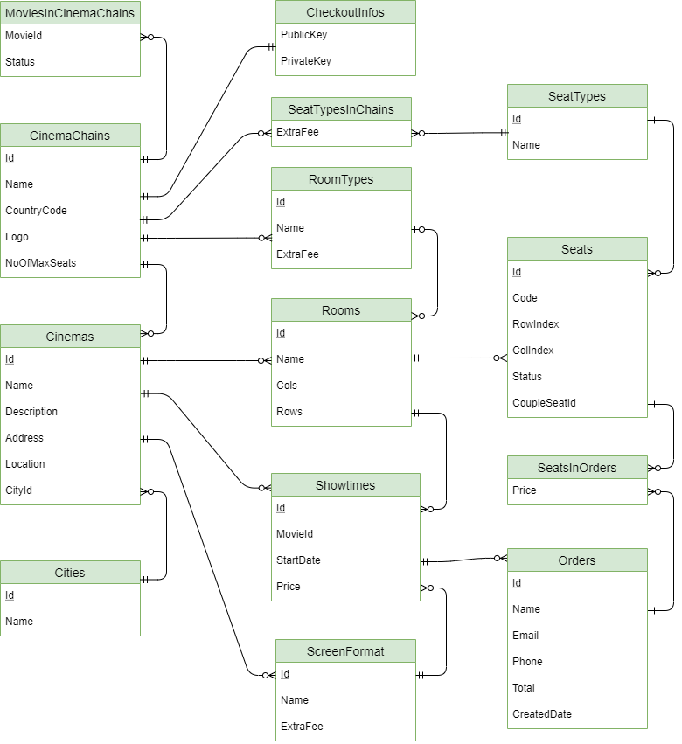

**Image 9 –** CinemaChainAPI

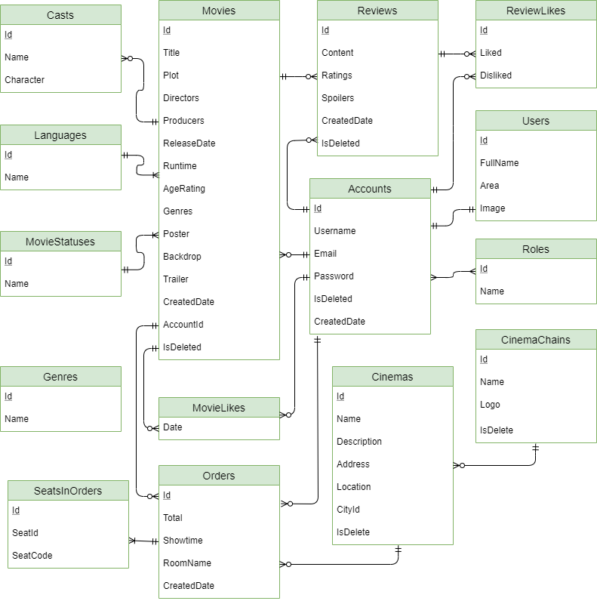

**Image 10 –** MovieReviews&TicketAPI

# 

# CHAPTER 3. FUNDATMENTALS



## Overview of ASP.NET Core

### Introduction to ASP.NET Core

ASP.NET Core is a cross-platform, high-performance, free and open-source web framework and successor to ASP.NET, developed by Microsoft and the community.

### Features

- No-compile developer experience (i.e. compilation is continuous, so that the developer does not have to invoke the compilation command).[3]

- Moduler framework distributed as NuGet packages.[3]

- A unified story for building web UI and web APIs (i.e. both the same).[3]

- A light-weight and modular HTTP request pipeline.[3]

- Build and run cross-platform ASP.NET Core apps on Windows, Mac, and Linux.[3]

- Open-source and community-focused.[3]

- Inbuilt support for dependency injection.[3]

### Introduction to Web APIs in ASP.NET Core

ASP.NET makes it easy to build services that reach a broad range of clients, including browsers and mobile devices. With ASP.NET you use the same framework and patterns to build both web pages and services, side-by-side in the same project.[4]

ASP.NET was designed for modern web experiences. Endpoints automatically serialize your classes to properly formatted JSON out of the box. No special configuration is required. Of course, serialization can be customized for endpoints that have unique requirements.[4]

ASP.NET lets you define routes and verbs inline with your code, using attributes. Data from the request path, query string, and request body are automatically bound to method parameters.[4]

.NET provides first class support for HTTPS out of the box. Automatically generate a test certificate and easily import it to enable local HTTPS so you run, and debug, your apps the way they are intended to be... secured.[4]

### Advantages of ASP.NET Core

- Fast - It is a lightweight, high-performance web framework.[5]

- Integration of Modern UI Framework - ASP.NET Core support modern, a Client-side framework like AngularJS, ReactJS and React with Redux etc. ASP.NET framework supports client-side framework templates like AngularJS, ReactJS and React with Redux etc.[5]

- Hosting - It has the ability to host on IIS, Apache, Docker or Self Hosting.[5]

- Cross Platform - ASP.NET Core web application can run on Windows, Mac, Linux development tools.[5]

- Support Built-In Dependency Injection - It supports built-in Dependency Injection.[5]

- Supports Modular - It support modular HTTP request.[5]

- Open-Source - It is an open-source and community-focused web framework.[5]

### ASP.NET Core in Project

Use to build Web API CinemaChain and Web API MovieReviewsAndTickets.

## Angular Framework

### Introduction to Angular

Angular [6] is a platform and framework for building single-page client applications using HTML and TypeScript. Angular is written in TypeScript. It implements core and optional functionality as a set of TypeScript libraries that you import into your apps.

### Angular concepts

- Module: Angular NgModules differ from and complement JavaScript (ES2015) modules. An NgModule declares a compilation context for a set of components that is dedicated to an application domain, a workflow, or a closely related set of capabilities. An NgModule can associate its components with related code, such as services, to form functional units.

- Component: Every Angular application has at least one component, the root component that connects a component hierarchy with the page document object model (DOM). Each component defines a class that contains application data and logic, and is associated with an HTML template that defines a view to be displayed in a target environment.

- Templates, directives, and data binding: A template combines HTML with Angular markup that can modify HTML elements before they are displayed. Template directives provide program logic, and binding markup connects your application data and the DOM.

- Services and dependency injection: A service class definition is immediately preceded by the @Injectable() decorator. The decorator provides the metadata that allows other providers to be injected as dependencies into your class.

- Routing: The Angular Router NgModule provides a service that lets you define a navigation path among the different application states and view hierarchies in your app.

### Angular in Project

In the project, movie reviews and tickets website is developed base on Angular version 10.1.3.

# CHAPTER 4. SYSTEM DESIGN



## Class Diagram



**Image 11 –** Class diagram of CinemaChainAPI



**Image 12 –** Class diagram of MovieReviewsAndTicketsAPI

### Class diagram description of “CinemaChain_API”

#### Class “Cinema”

|  |  |  |  |
| --- | --- | --- | --- |
| Property | Type | Access level | Description |
| Id | int | public | Cinema Id |
| Name | string | public | Cinema Name |
| Description | string | public | Description of cinema |
| Address | string | public | Address of cinema |
| Location | string | public | Location of cinema |
| CinemaChainId | CinemaChain | public | Cinema chain id that cinema belongs to |
| CityId | City | public | City id that cinema belongs to |

**Table 43 –** Cinema

#### Class “CinemaChain”

|  |  |  |  |
| --- | --- | --- | --- |
| Property | Type | Access level | Description |
| Id | int | public | Cinema chain Id |
| Name | string | public | Cinema chain Name |
| CountryCode | string | public | Country code of cinema chain |
| Logo | string | public | Logo of cinema chain |
| NoOfMaxSeats | ushort | public | Number of max seats in cinema chain |

**Table 44 –** CinemaChain

#### Class “City”

|  |  |  |  |
| --- | --- | --- | --- |
| Property | Type | Access level | Description |
| Id | int | public | City Id |
| Name | string | public | City Name |

**Table 45 –** City

#### Class “MovieInCinemaChain”

|  |  |  |  |
| --- | --- | --- | --- |
| Property | Type | Access level | Description |
| MovieId | Movie | public | Movie id belongs to cinema chain |
| CinemaChainId | CinemaChain | public | Cinema chain id |
| Status | byte | public | Status of movie in cinema chain: 0 is in theater, 1: in comming, 2: have no showtime schedule yet |

**Table 46 –** MoviesInCinemaChain

#### Class “Order”

|  |  |  |  |
| --- | --- | --- | --- |
| Property | Type | Access level | Description |
| Id | int | public | Order id belongs to cinema chain |
| Name | string | public | Name of customer in order |
| Email | string | public | Email of customer in order |
| Phone | string | public | Phone number of customer in order |
| ShowtimeId | Showtime | public | Showtime id in order |
| Total | decimal | public | Total order price |
| CreatedDate | DateTime | public | Create date of order |

**Table 47** **–** Order

#### Class “Room”

|  |  |  |  |
| --- | --- | --- | --- |
| Property | Type | Access level | Description |
| Id | int | public | Room id |
| Name | string | public | Room name |
| Cols | int | public | Number of columns in room |
| Rows | int | public | Number of rows in room |
| CinemaId | Cinema | public | Cinema id that room belongs to |
| RoomTypeId | int? | public | Room type id that room belongs to |

**Table 48 –** Room

#### Class “RoomType”

|  |  |  |  |
| --- | --- | --- | --- |
| Property | Type | Access level | Description |
| Id | int | public | Room type id |
| Name | string | public | Room type name |
| ExtraFee | decimal | public | Extra fee of room type |
| CinemaChainId | CinemaChain | public | Cinema chain id that room type belongs to |

**Table 49 –** RoomType

#### Class “ScreenFormat”

|  |  |  |  |
| --- | --- | --- | --- |
| Property | Type | Access level | Description |
| Id | int | public | Screen format id |
| Name | string | public | Screen format name |
| ExtraFee | decimal | public | Extra fee of screen format |
| CinemaChainId | CinemaChain | public | Cinema chain id that screen format belongs to |

**Table 50 –** ScreenFormat

#### Class “Seat”

|  |  |  |  |
| --- | --- | --- | --- |
| Property | Type | Access level | Description |
| Id | int | public | Seat id |
| Code | string | public | Seat code |
| RowIndex | int | public | Row index of seat |
| ColIndex | int | public | Col index of seat |
| RoomId | Room | public | Room id that seat belongs to |
| SeatTypeId | SeatType | public | Seat type id that seat belongs to |
| CoupleSeatA | Seat | public | Couple seat that point to seat |
| CoupleSeatId | int? | public | Couple seat id |
| CoupleSeatB | Seat | public | Couple seat that point to seat |

**Table 51 –** Seat

#### Class “SeatInOrder”

|  |  |  |  |
| --- | --- | --- | --- |
| Property | Type | Access level | Description |
| OrderId | Order | public | Order id that seats in order belongs to |
| SeatId | Seat | public | Seat id that seat seats in order belongs to |
| Price | decimal | public | Total seat price in order |

**Table 52 –** SeatsInOrder

#### Class “SeatType”

|  |  |  |  |
| --- | --- | --- | --- |
| Property | Type | Access level | Description |
| Id | int | public | Seat type id |
| Name | string | public | Seat type name |

**Table 53 –** SeatType

#### Class “SeatTypeInChain”

|  |  |  |  |
| --- | --- | --- | --- |
| Property | Type | Access level | Description |
| SeatTypeId | SeatType | public | Seat type id that seat type in chain belongs to |
| CinemaChainId | CinemaChain | public | Cinema chain id that seat type in chain belongs to |
| ExtraFee | decimal | public | Extra fee of seat in cinema chain |

**Table 54 –** SeatTypeInChain

#### Class “Showtime”

|  |  |  |  |
| --- | --- | --- | --- |
| Property | Type | Access level | Description |
| Id | int | public | Showtime id |
| MovieId | int | public | Movie id of showtime |
| CinemaId | Cinema | public | Cinema id that showtime belongs to |
| RoomId | Room | public | Room id that showtime belongs to |
| ScreenFormatId | ScreenFormat | public | Screen format id that showtime belongs to |
| StartDate | DateTime | public | Start date of showtime |
| Price | decimal | public | Price of showtime |

**Table 55 –** Showtime

#### Class “CheckoutInfo”

|  |  |  |  |
| --- | --- | --- | --- |
| Property | Type | Access level | Description |
| CinemaChainId | CinemaChain | public | Cinema chain id that checkout info belongs to |
| PublicKey | string | public | Public key of stripe checkout |
| PrivateKey | string | public | Public key of stripe checkout |

**Table 56 –** CheckoutInfo

### Class digram descripton of “MovieReviewsAndTickets”

#### Class “User”

|  |  |  |  |
| --- | --- | --- | --- |
| Property | Type | Access level | Description |
| Id | int | public | User id |
| FullName | string | public | User full name |
| Area | string | public | User area |
| Image | string | public | User profile picture |
| AccountId | Account | public | Each user has an account id |

**Table 57 –** User

#### Class “Account”

|  |  |  |  |
| --- | --- | --- | --- |
| Property | Type | Access level | Description |
| User | User | public | Get user data |

**Table 58 –** Account

#### Class “Cast”

|  |  |  |  |
| --- | --- | --- | --- |
| Property | Type | Access level | Description |
| MovieId | Movie | public | Movie id that cast belongs to |
| Name | string | public | Name of actor |
| Character | string | public | Name of actor in movie |

**Table 59 –** Cast

#### Class “Cinema”

|  |  |  |  |
| --- | --- | --- | --- |
| Property | Type | Access level | Description |
| Id | int | public | Cinema id |
| Name | string | public | Cinema name |
| Description | string | public | Description of cinema |
| Address | string | public | Address of cinema |
| Location | string | public | Location of cinema |
| CinemaChainId | CinemaChain | public | Cinema chain id that cinema belongs to |
| CityId | int | public | City id of cinema |

**Table 60 –** Cinema

#### Class “CinemaChain”

|  |  |  |  |
| --- | --- | --- | --- |
| Property | Type | Access level | Description |
| Id | int | public | Cinema chain id |
| Name | string | public | Cinema chain name |
| Logo | string | public | Cinema chain logo |
| NoOfMaxSeats | ushort | public | Number of max seats in cinema chain |

**Table 61 –** CinemaChain

#### Class “Genre”

|  |  |  |  |
| --- | --- | --- | --- |
| Property | Type | Access level | Description |
| Id | byte | public | Genre id |
| Name | string | public | Genre name |

**Table 62 –** Genre

#### Class “Language”

|  |  |  |  |
| --- | --- | --- | --- |
| Property | Type | Access level | Description |
| Id | int | public | Language id |
| Name | string | public | Language name |

**Table 63 –** Language

#### Class “Movie”

|  |  |  |  |
| --- | --- | --- | --- |
| Property | Type | Access level | Description |
| Id | int | public | Movie id |
| OriginalTitle | string | public | Original title of movie |
| Title | string | public | Title of movie |
| Plot | string | public | Plot of movie |
| Directors | string | public | Directors of movie |
| Producers | string | public | Producers of movie |
| ReleaseDate | DateTime | public | Release date of movie |
| Runtime | ushort | public | Movie length |
| AgeRating | string | public | Age rating of movie |
| Genres | Int[] | public | Genres of movie |
| Poster | string | public | Poster of movie |
| Backdrop | string | public | Backdrop of movie |
| Trailer | string | public | Trailer of movie |
| LanguageId | Language | public | Language id that movie belongs to |
| MovieStatusId | MovieStatus | public | Movie status id that movie belongs to |

**Table 64 –** Movie

#### Class “MovieLike”

|  |  |  |  |
| --- | --- | --- | --- |
| Property | Type | Access level | Description |
| AccountId | Account | public | Account id that movie like belongs to |
| MovieId | Movie | public | Movie id that movie like belongs to |

**Table 65 –** MovieLike

#### Class “MovieStatus”

|  |  |  |  |
| --- | --- | --- | --- |
| Property | Type | Access level | Description |
| Id | byte | public | Movie status id |
| Name | string | public | Movie status name |

**Table 66 –** MovieStatus

#### Class “Order”

|  |  |  |  |
| --- | --- | --- | --- |
| Property | Type | Access level | Description |
| Id | int | public | Order id |
| Total | decimal | public | Total price of order |
| Showtime | DateTime | public | Showtime in order |
| RoomName | string | public | Room name in order |
| AccountId | Account | public | Account id that order belongs to |
| CinemaId | Cinema | public | Cinema id that order belongs to |
| MovieId | Movie | public | Movie id that order belongs to |

**Table 67 –** Order

#### Class “Review”

|  |  |  |  |
| --- | --- | --- | --- |
| Property | Type | Access level | Description |
| Id | int | public | Review id |
| Content | string | public | Content of review |
| Ratings | byte | public | Rating for movie |
| Spoilers | bool | public | Review content reveal content or not |
| CreatedDate | DateTime | public | Created date of review |
| MovieId | Movie | public | Movie id that review belongs to |
| AccountId | Account | public | Account id that review belongs to |

**Table 68 –** Review

#### Class “ReviewLike”

|  |  |  |  |
| --- | --- | --- | --- |
| Property | Type | Access level | Description |
| ReviewId | Review | public | Review id that review like belongs to |
| AccountId | Account | public | Account id that review like belongs to |
| Liked | bool | public | Review like |
| DisLike | bool | public | Review dislike |

**Table 69 –** ReviewLike

#### Class “Role”

|  |  |  |  |
| --- | --- | --- | --- |
| Property | Type | Access level | Description |
| Id | Review | public | Role id |
| Name | Account | public | Role name |

**Table 70 –** Role

#### Class “SeatsInOrder”

|  |  |  |  |
| --- | --- | --- | --- |
| Property | Type | Access level | Description |
| OrderId | Order | public | Order id that seats in order belongs to |
| SeatId | Seat | public | Seat id that seats in order belongs to |
| SeatCode | string | public | Seat code in order |

**Table 71 –** SeatsInOrder

## Sequence Diagram

### Login

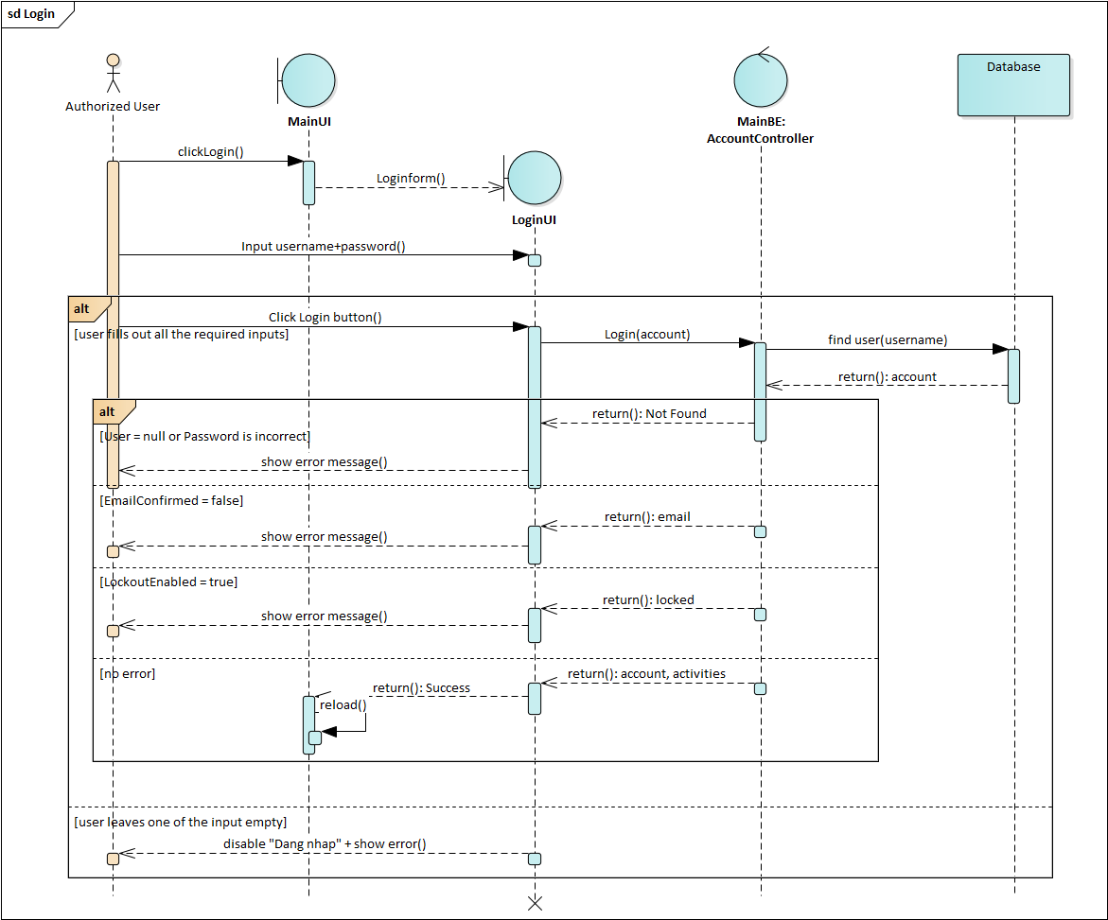

**Image 13 –** Sequence diagram Login

### Add Movie

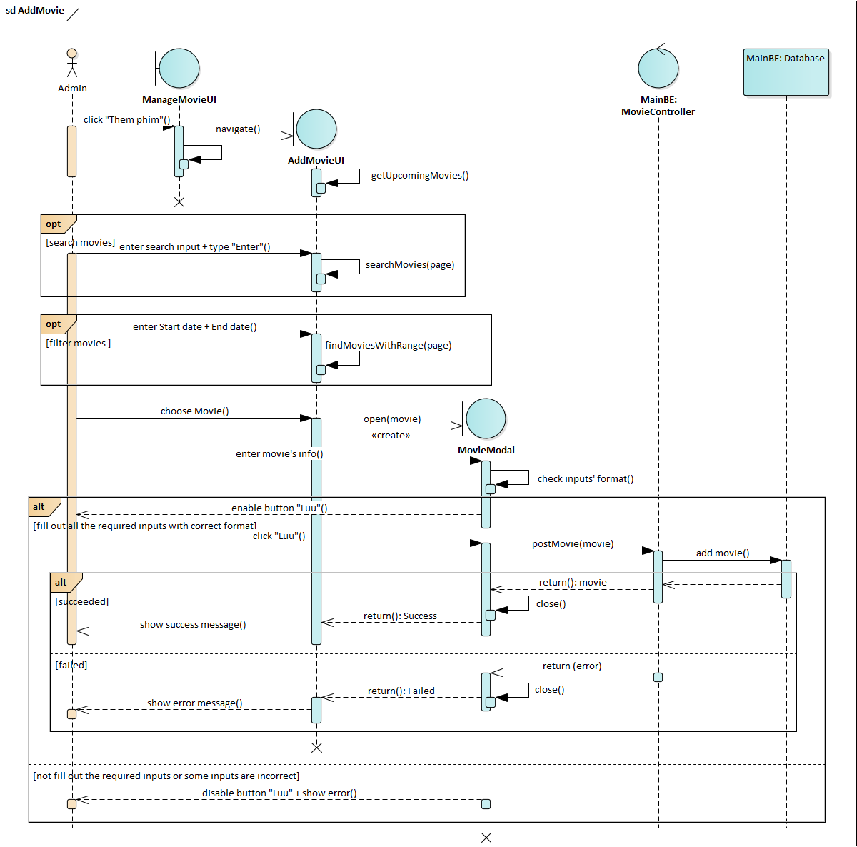

**Image 14 –** Sequence diagram Add Movie

### Write Review and Rate

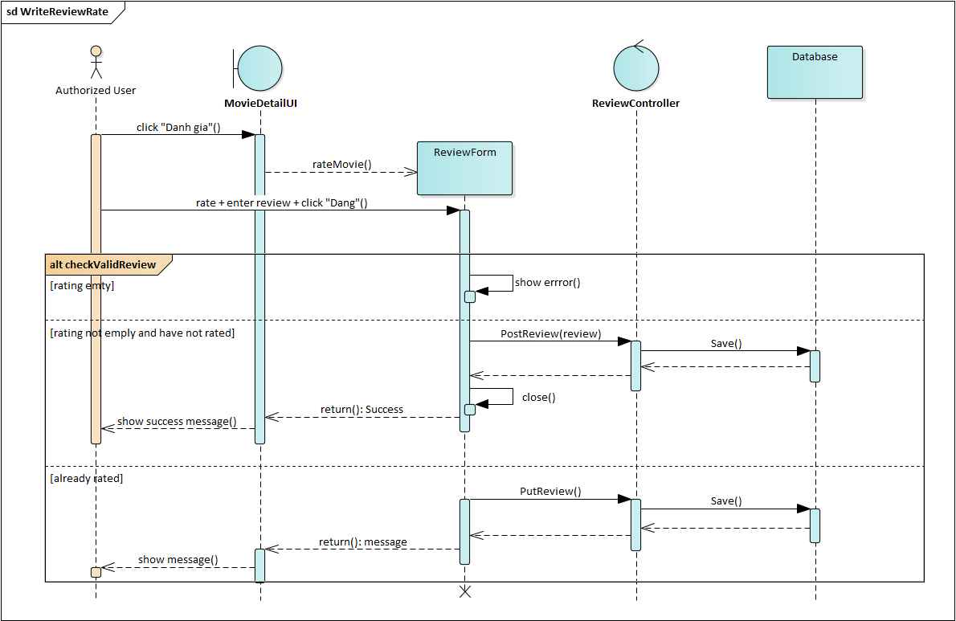

**Image 15 –** Sequence diagram Write Review and Rate

### Book tickets



**Image 16 –** Sequence diagram Book Tickets

## Activity Diagram

### Add Movie



**Image 17 –** Activity diagram Add Movie

### Write Review and Rate



**Image 18 –** Activity diagram Write Review and Rate

## State Machine Diagram

### Login



**Image 19 –** State Machine diagram Login

### Book Tickets



**Image 20 –** State Machine diagram Book Tickets

## Component Diagram

### CinemaChain API



**Image 21 –** Component diagram of CinemaChain_API

|  |  |
| --- | --- |
| Name | Description |
| Models | Contains Entity Framework Core entities (classes) to work with the database. |
| Controllers | Classes that handle the API requests from the Frontend. They retrieve model data and return to the Frontend. |
| ViewModels | Contains classes which are combinations of many models or a model with more attributes required for a particular view in Frontend. |
| EF Core | An open-source, lightweight, extensible and a cross-platform data access technology which is used to access data in the SQL Server. |
| Cinemachain database | The CinemaChains database in SQL Server. |

**Table 72 –** Component of CinemaChainAPI description

### Movie Reviews & Tickets API



**Image 22 –** Component diagram of Mainbackend_API

|  |  |
| --- | --- |
| Name | Description |
| Models | Contains Entity Framework Core entities (classes) to work with the database. |
| Controllers | Classes that handle the API requests from the Frontend. They retrieve model data and return to the Frontend. |
| ViewModels | Contains classes which are combinations of many models or a model with more attributes required for a particular view in Frontend. |
| Services | Contains classes implementing services used for MainBackend API (SendGrid email service). |
| Helpers | Contains classes keeping the static strings to use accross the project. |
| EF Core | An open-source, lightweight, extensible and a cross-platform data access technology which is used to access data in the SQL Server. |
| MovieReviews database | The MovieReviews database stored in SQL Server. |

**Table 73 –** Component of MainBackend description

## Interface Design

### Login dialog

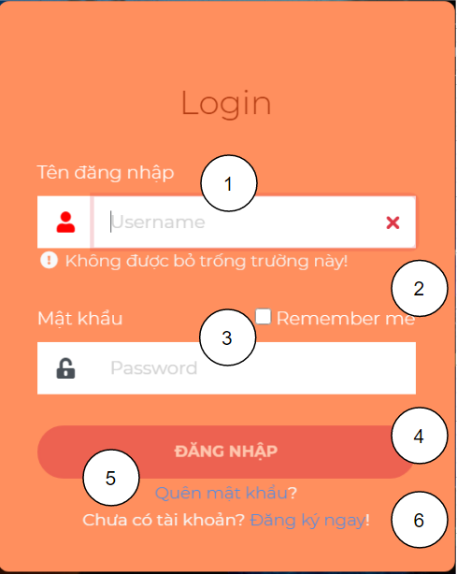

**Image 23 –** Login dialog

|  |  |  |  |  |  |
| --- | --- | --- | --- | --- | --- |
| No | Name | Required | Format | Reference | Action |
| 1 | Username input | True | Input |  | For users to enter data |
| 2 | Remember checkbox | No | Input |  | For users to check |
| 3 | Password input | Yes | Input |  | For users to enter data |
| 4 | Login button |  | Button |  | When clicked send user’s authorization to MainBackend API |
| 5 | Reset password link |  | Link | Reset password page | When clicked go to Reset password page |
| 6 | Register link |  | Link | Register page | When clicked go to Register page |

**Table 74 –** Login dialog objects

### Seats of showtime screen

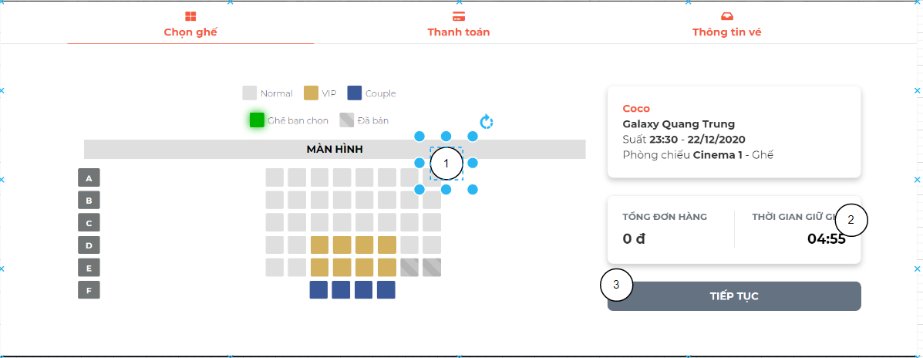

**Image 24 –** Seats of showtime screen

|  |  |  |  |  |  |
| --- | --- | --- | --- | --- | --- |
| No | Name | Required | Format | Reference | Action |
| 1 | Seat |  | Li | Data from CinemaChain API | When clicked turn green, button “Tiếp tục” enables |
| 2 | Countdown |  | Span |  | When reaching “0:00”, a dialog appears asking user to restart the order. |
| 3 | Continue button |  | Button |  | When clicked, navigate to “Thanh toán page” |

**Table 75 –** Seats of showtime screen objects

### Review dialog

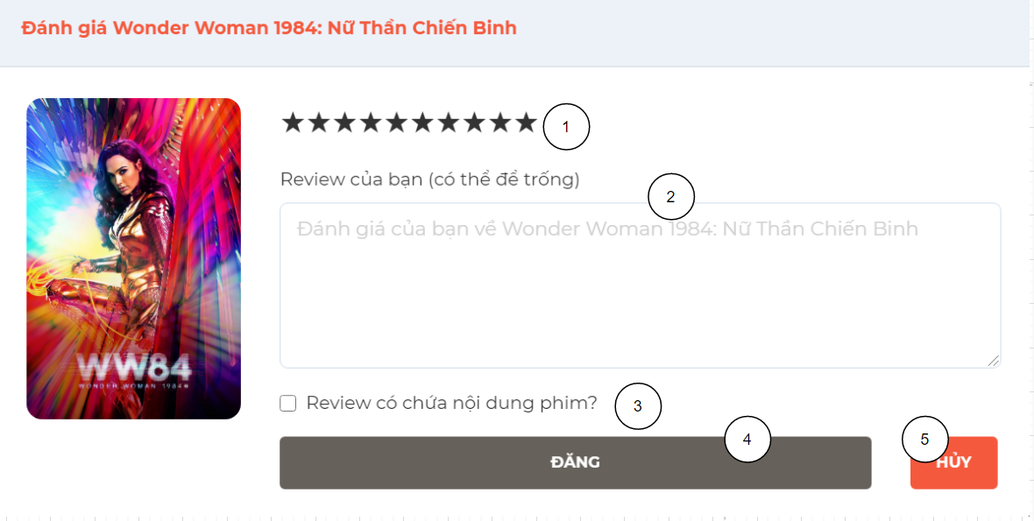

**Image 25 –** Review dialog

|  |  |  |  |  |  |
| --- | --- | --- | --- | --- | --- |
| No | Name | Required | Format | Reference | Action |
| 1 | Rating | Yes | Ngb Rating | Data from MainBackend API | For users to choose rating |
| 2 | Content input | No | Text area | Data from MainBackend API | For users to enter data |
| 3 | Spoiler checkbox | No | Input | Data from MainBackend API | For users to check |
| 4 | Post button |  | Button |  | When clicked send review to MainBackend API |
| 5 | Cancel button |  | Button |  | When clicked, the dialog is closed |

**Table 76 –** Review dialog objects

# CHAPTER 5. IMPLEMENTATION AND TESTING

## 5.1. System Architecture

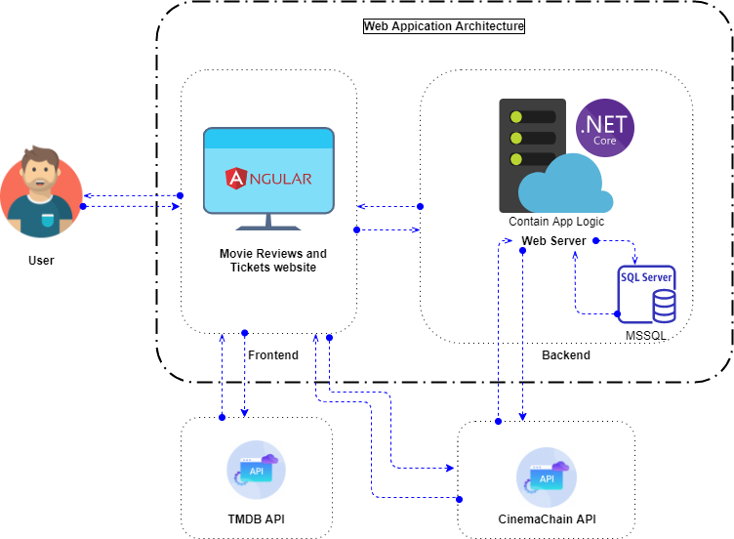

**Image 26 –** Overview of architectural design for system

A System Architecture is the fundamental organization of a system, embodied in its components, their relationships to each other and the environment, and the principles governing its design and evolution.

As you can see, the Movie Reviews & Tickets internal system consists of two subsystem which is:

- Frontend: is where user interacts with the website. The Frontend is developed by Angular 10 and Bootstrap 4.

- Backend (Main Backend or MovieReviewsAndTickets API): an ASP .Net Core 3.1 Web API connects with the SQL Server database and handles requests made from Frontend.

Externally, the system also communicates with the TMDb API and the CinemaChain API. The TMDb API is an API service is for those interested in using available movie, TV show or actor images data to intergrate in their application. We need this API not only for its available movie data so that user won’t waste much time when adding a movie, but it’s also because we can use the movie’s ids of TMDb database to synchonize our movie data with the CinemaChain API and make request for showtimes data. The CinemaChain API is where our system request for showtimes data so user can book tickets. Since there’s no Showtimes API service available for non profit organization so the CinemaChain API is an ASP Net Core Web API emulating <https://tix.vn/sdk> and other tickets API services.

## 5.2. Tools in Project

|  |  |
| --- | --- |
| Tool | Name |
| Environment | .Net Core |
| IDE | Visual Studio 2019 |
| Visual Studio Code |
| Dbms | SQL Server 2017 |
| Source control | Github, Git bash |
| Modelling tools | Draw.io, Enterprise Architect |

**Table 77 –** Tools using for project

## 5.3. Technologies in Project

In the project, the technologies will use which is listed in the table below:

|  |  |
| --- | --- |
| Transmission Protocol | REST API |
| JSON Web Token |
| User Interface | Angular 10.1.3 |
| System Technologies | ASP.NET Core API 3.1 |
| Entity Framework Core |
| Databases | Microsoft SQL Server 2017 |
| Services | SendGrid (Email Sender) |
| Twilio (SMS message) |
| Stripe (Payment Gateway) |
| Firebase (Uploading user’s image) |
| Thirdly Party | TMDB ( The Movie Database API) |
| Ipinfo.io ( Get Location) |

**Table 78 –** Technologies using for project

After we finish developing the application, we use these hosting services to deploy our website:

- Database and Backend : using Somee to deploy.

- Frontend : using Firebase to deploy

## 5.4. Test Plan

In this project, we use Black box Testing method to test main functions of the application. The biggest advantage of Black box Testing is that it is quite suitable for testing a large part of code or main functions of the system, which is very convenient for rapid software development. The functions will be tested are:

-Authorized user: Login.

-Guest: Book tickets.

-Admin: Add a movie.

### 5.4.1. Test Scenarios

|  |  |  |  |
| --- | --- | --- | --- |
| # | Actor | Function | Description |
| 1 | Authorized user | Login | Test the website’s response when user enters inputs in the “Đăng nhập” dialog and takes actions on it. |
| 2 | Guest | Book tickets | Test the website’s response when user enters the “Đặt vé” screen and takes actions on it. |
| 3 | Admin | Add a movie | Test the website’s response when user enters inputs in the “Thêm phim” dialog and takes actions on it. |

**Table 79 –** Test Scenarios

### 5.4.2. Test Result

#### 5.4.2.1. Authorized user – Login

|  |  |  |  |  |  |  |
| --- | --- | --- | --- | --- | --- | --- |
| ID | Description | Test steps | Test data | Expected Result | Actual Result | Status |
| TC_LI_01 | Test response of the website when user enters correct authentication | Click the “Đăng nhập” button on the navigation bar.  Enter username  Enter password  Click “Đăng nhập” button | Step 2: Username = “tnnhuquynh”  Step 3: Password = “121899” | User is logged in to the website with Super Admin role, website navigates to Admin page | As expected | Pass |
| TC_LI_02 | Test response of the website when user enters incorrect authentication | Click the “Đăng nhập” button on the navigation bar.  Enter username  Enter password  Click “Đăng nhập” button | Step 2: Username = “tnnhuquynh”  Step 3: Password = “tnnhuquynh” | Error appears above the Username input “Tài khoản không tồn tại” | As expected | Pass |
| TC_LI_03 | Test response of the website when user enters correct authentication but unconfirmed one | Click the “Đăng nhập” button on the navigation bar.  Enter username  Enter password  Click “Đăng nhập” button | Step 2: Username = “tuduyen99”  Step 3: Password = “121899” | Error appears above the Username input “Chưa xác nhận email” | As expected | Pass |

**Table 80 –** Test results of Login function

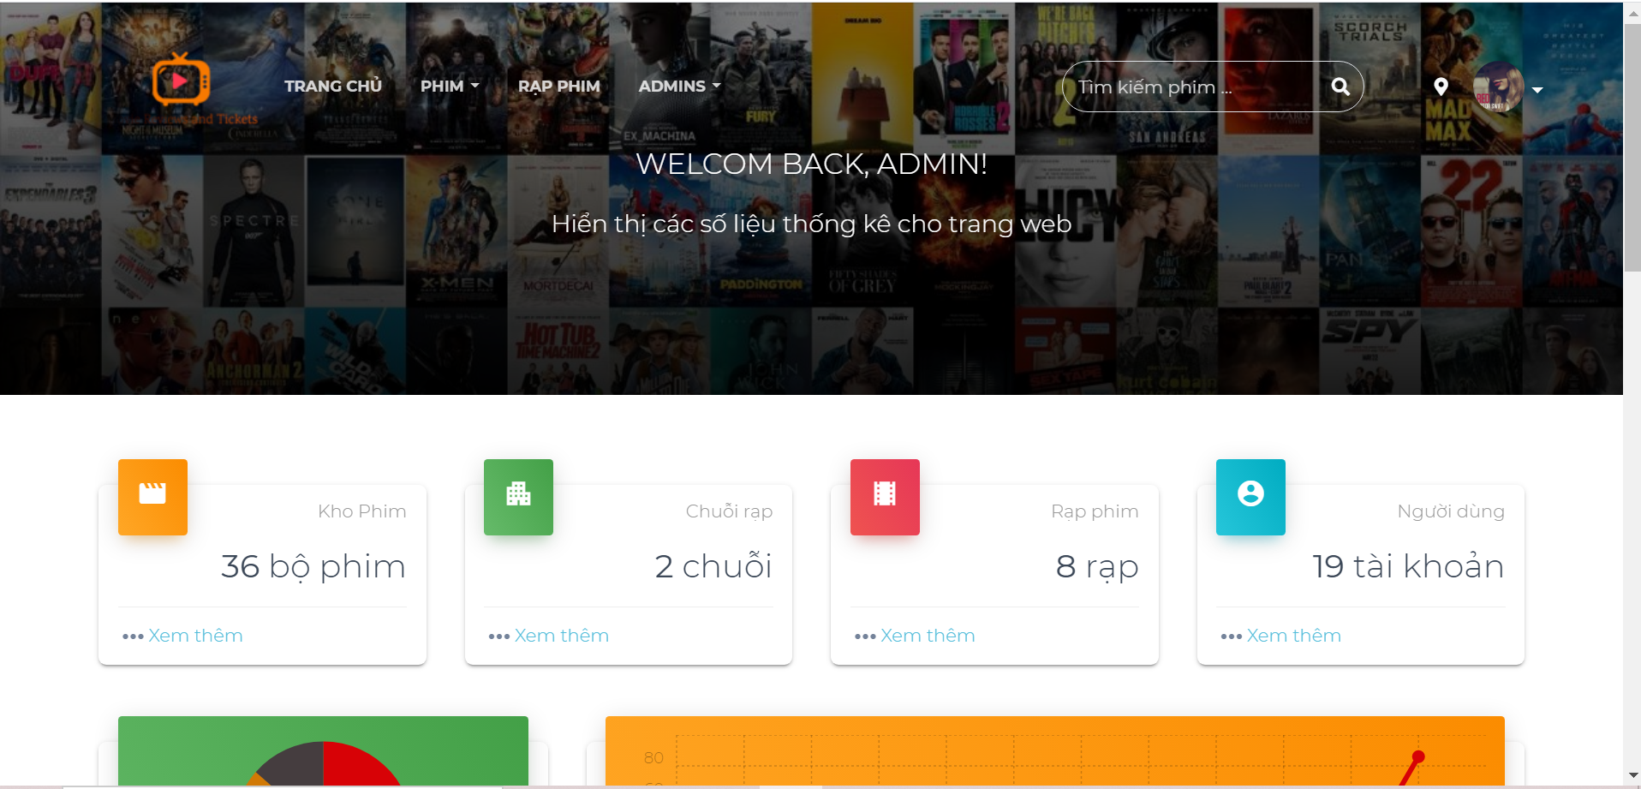

**Image 27 –** Expected & Actual result of TC_LI_01

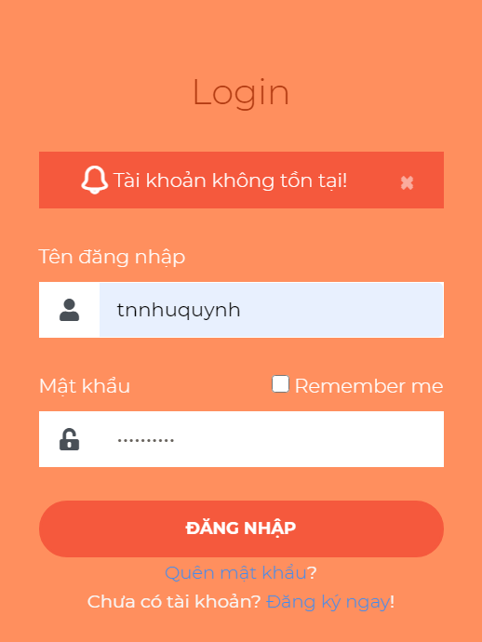

**Image 28** **–** Expected & Actual result of TC_LI_02

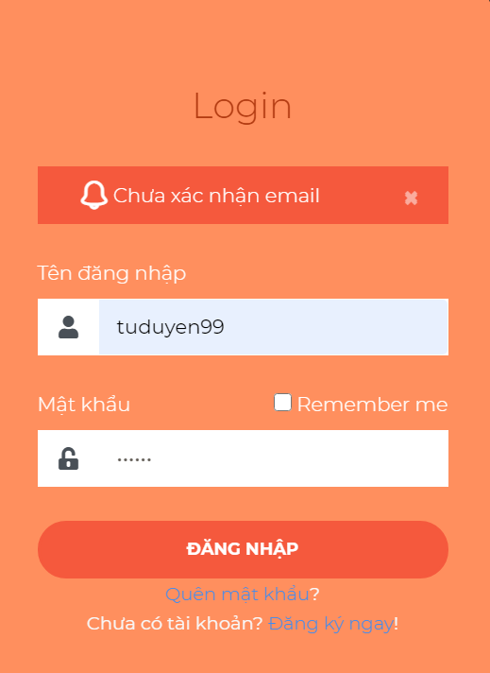

**Image 29 –** Expected & Actual result of TC_LI_03

#### 5.4.2.2. Guest – Book tickets

|  |  |  |  |  |  |  |
| --- | --- | --- | --- | --- | --- | --- |
| ID | Description | Test steps | Test data | Expected Result | Actual Result | Status |
| TC_BT_01 | Test response of the website when user enters correct checkout information | 1. Go to “Lịch chiếu” page of movie “Coco” 2. Pick showtime “23:30” 3. Pick seat “E7” 4. Click “Tiếp tục” button 5. Enter “Họ và tên” input 6. Enter Email 7. Enter “Số điện thoại” input 8. Click “Thanh toán” 9. Fill in Strip checkout form 10. Click “Pay ...” | * Step 5: “Họ và tên” = “Quỳnh” * Step 6: Email = “tonnunhuquynh99@gmail.com” * Step 7: “Số điện thoại” = “0932228092” * Step 9: * Email = “17110214@student.hcmute.edu.vn” * Card number = 4242 4242 4242 42424 * MM/YY: 02/23 * CVC: 123 | Website naviagates to “Thông tin vé” page | As expected | Pass |
| TC_BT_02 | Test response of the website when the reservation time is over | 1. Go to “Lịch chiếu” page of movie “Coco” 2. Pick showtime “23:30” 3. Wait for the countdown at the right side of the screen is up |  | Error dialog appears “Hết thời gian giữ ghế, hãy thực hiện lại đơn hàng của bạn” | As expected | Pass |

**Table 81 –** Test results of Book tickets function

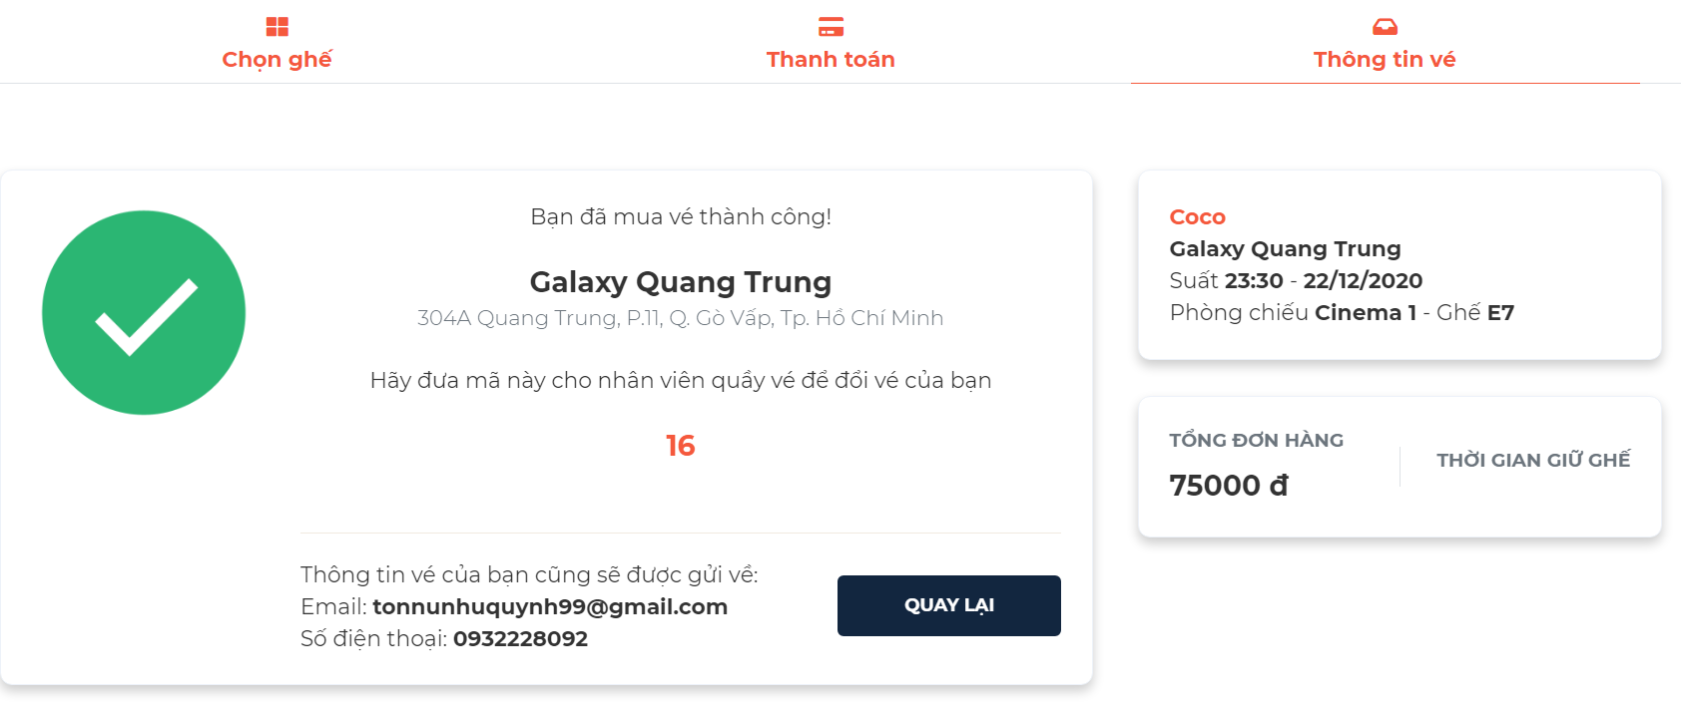

**Image 30 –** Expected & Actual result of TC_BT_01

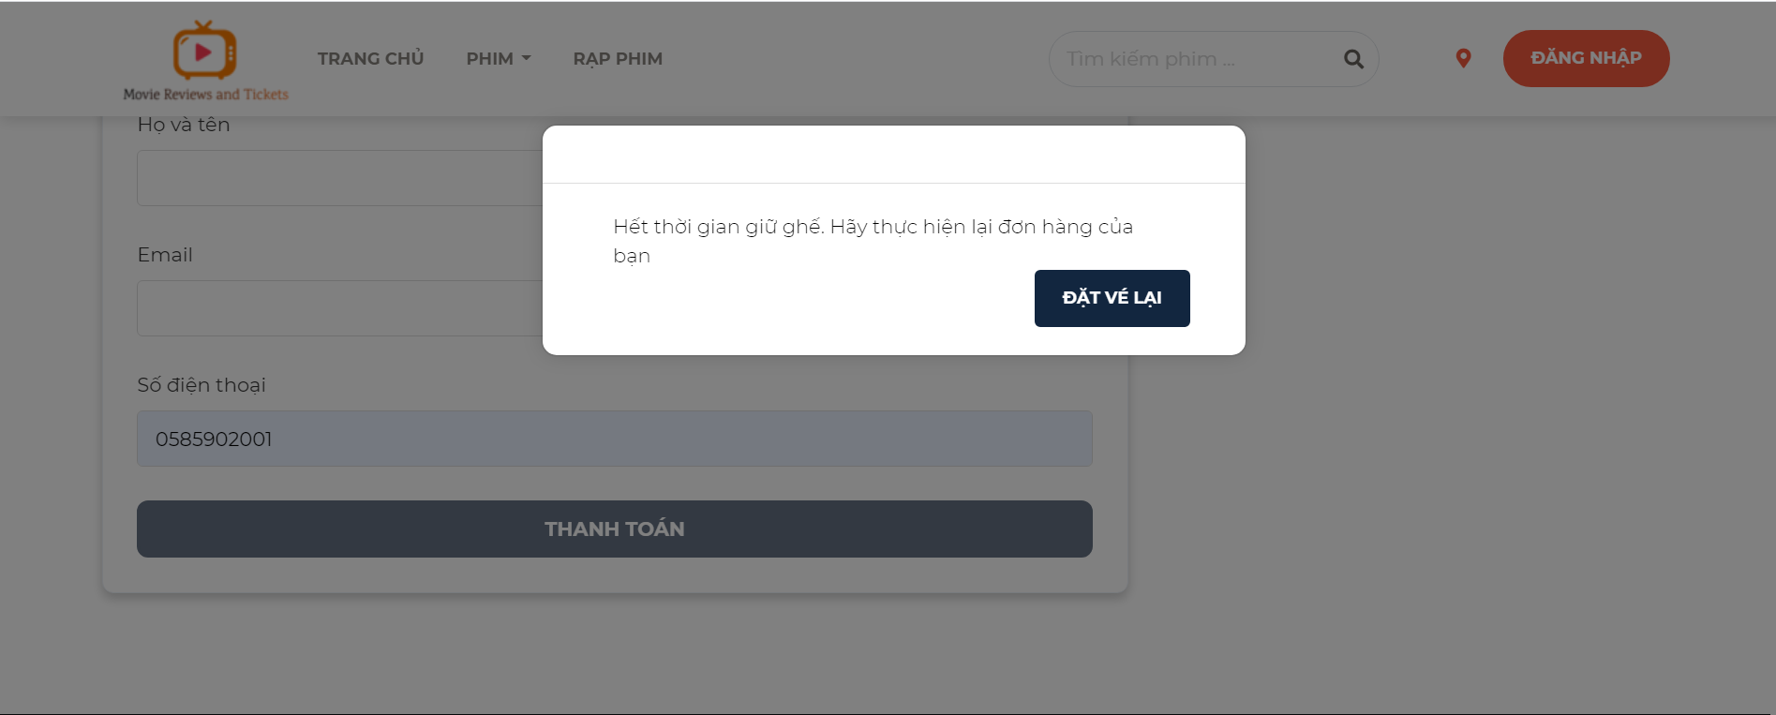

**Image 31 –** Expected & Actual result of TC_BT_02

#### 5.4.2.3. Admin – Add a movie

|  |  |  |  |  |  |  |
| --- | --- | --- | --- | --- | --- | --- |
| ID | Description | Test steps | Test data | Expected Result | Actual Result | Status |
| TC_AM_01 | Test response of the website when user add a non existed movie | Go to the “Quản lý phim” page  Click “Thêm phim” button  Pick movie “Ponyo” and click the plus icon button  Enter “Tựa Việt” input  Pick “Ngôn ngữ”  Pick “Trạng phái phim”  Pick “Thể loại”  Click “Lưu” button | Step 4: “Tựa Việt” = “Ponyo”  Step 5: “Ngôn ngữ” = “Tiếng Anh”  Step 6: “Trạng phái phim” = “Chưa có lịch chiếu”  Step 7: “Thể loại” = “Hoạt hình”, “Phiêu lưu” | A green message appears at top right corner of the screen “Thêm phim thành công” | As expected | Pass |
| TC_AM_02 | Test response of the website when user add an existed movie | Go to the “Quản lý phim” page  Click “Thêm phim” button  Pick movie “Wonder woman 1984” and click the plus icon button  Enter “Tựa Việt” input  Pick “Ngôn ngữ”  Pick “Trạng phái phim”  Pick “Thể loại”  Click “Lưu” button | Step 4: “Tựa Việt” = “Wonder woman 1984”  Step 5: “Ngôn ngữ” = “Tiếng Anh”  Step 6: “Trạng phái phim” = “Đang chiếu”  Step 7: “Thể loại” = “Hành động”, “Phiêu lưu” | A red message appears at top right corner of the screen “Phim đã được thêm rồi” | As expected | Pass |

**Table 82 –** Test results of Add a movie function

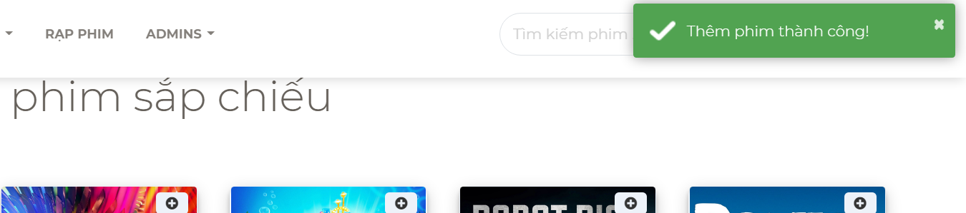

**Image 32 –** Expected & Actual result of TC_AM_01

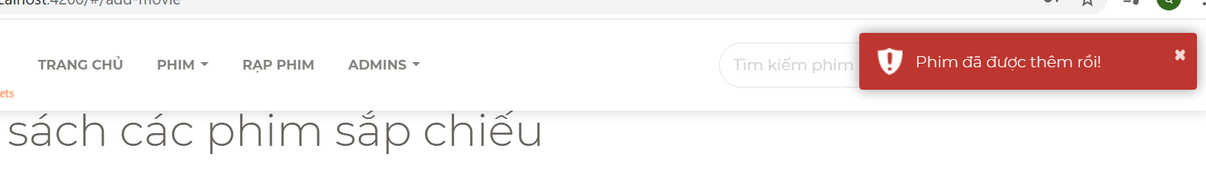

**Image 33 –** Expected & Actual result of TC_AM_02

# CHAPTER 6. CONCLUSION

## 6.1. Results

The project is 90% complete, providing an overview of the architecture and system design. From there, we have an overview for the operation of the movie review and tickets system. We have applied our learned knowledge as well as new knowledge to build our website.

* Website URL: [https://movie-reviews-and-tickets.web.app](https://movie-reviews-and-tickets.web.app/)
* Source: https://github.com/TonNuNhuQuynh/TLCN_17110116_17110214.git

## 6.2. Advantages

* User-friendly interface.
* Easy maintenance and development.

## 6.3. Disadvantages

* Performance has not been assessed with the curent security solutions.
* Lack of practical experience in building system architecture.
* Processing performance is not good because of using a free implementation package.

## 6.4. Development strategy

* Add some machine learning algorithms to suggest some movies according to user preferences.
* Continue to conplete the project and apply it to stores to keep updating system and fixing bugs.

# REFERENCES

[1] MONET company (2020). Moveek. Retrieved from <https://moveek.com/> .

[2] Amazon company (1990). IMDb. Retrieved from <https://www.imdb.com/>.

[3] Wikipedia (12/2020). ASP.NET Core. Retrieved from https://en.wikipedia.org/wiki/ASP.NET_Core

[4] Microsoft (2020). ASP.NET Web APIs. Retrieved from <https://dotnet.microsoft.com/apps/aspnet/apis>

[5] Shrimant Telgave (2018). What ASP.NET Core Is And Advantages Of Using It. Retrieved from <https://www.c-sharpcorner.com/article/what-is-asp-net-core-and-advantages-of-using-asp-net-core-how-to-setup-asp-net/>.

[6] Angular (2020). Introduction to the Angular Docs. Retrieved from <https://angular.io/docs>.

[7] Angular (2020). Introduction to Angular concepts. Retrieved from <https://angular.io/guide/architecture>